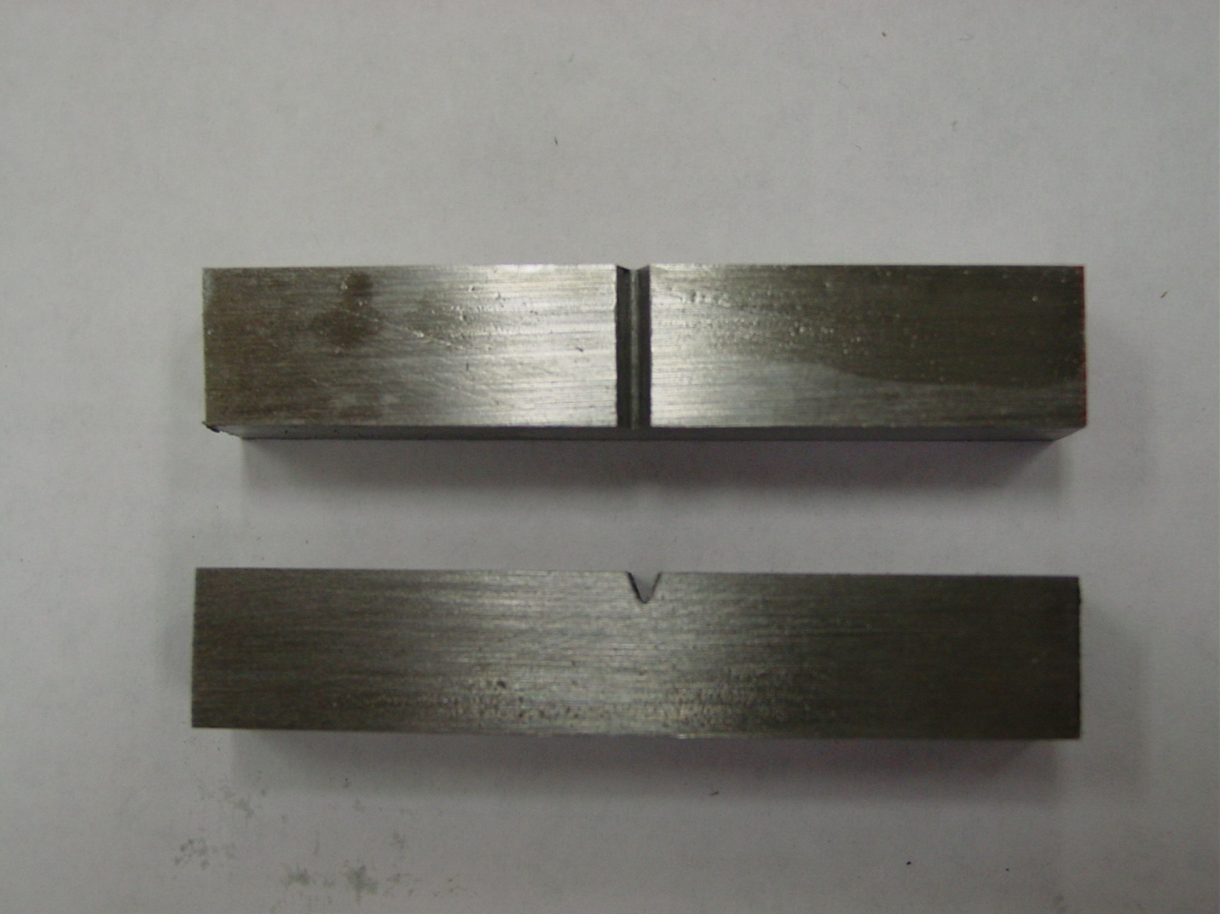

Figure 1 – Charpy specimen

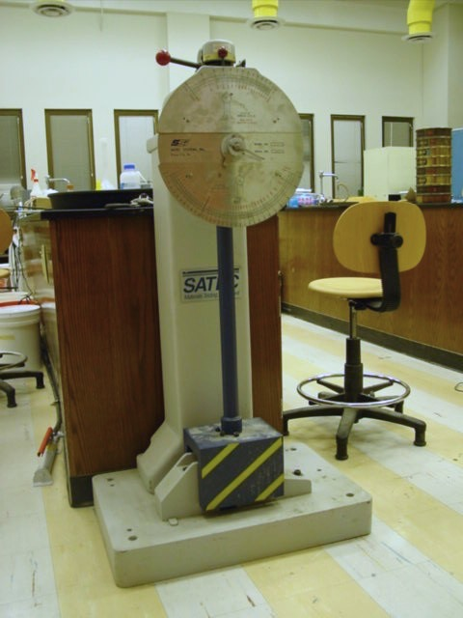

Figure 2 – Charpy V-notch tester (alternate)

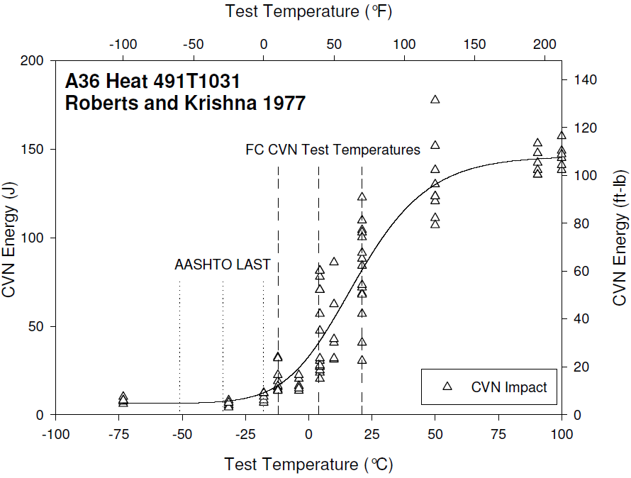

???? Figure 7 – Typical Charpy results (Roberts and Krishna 1977)

