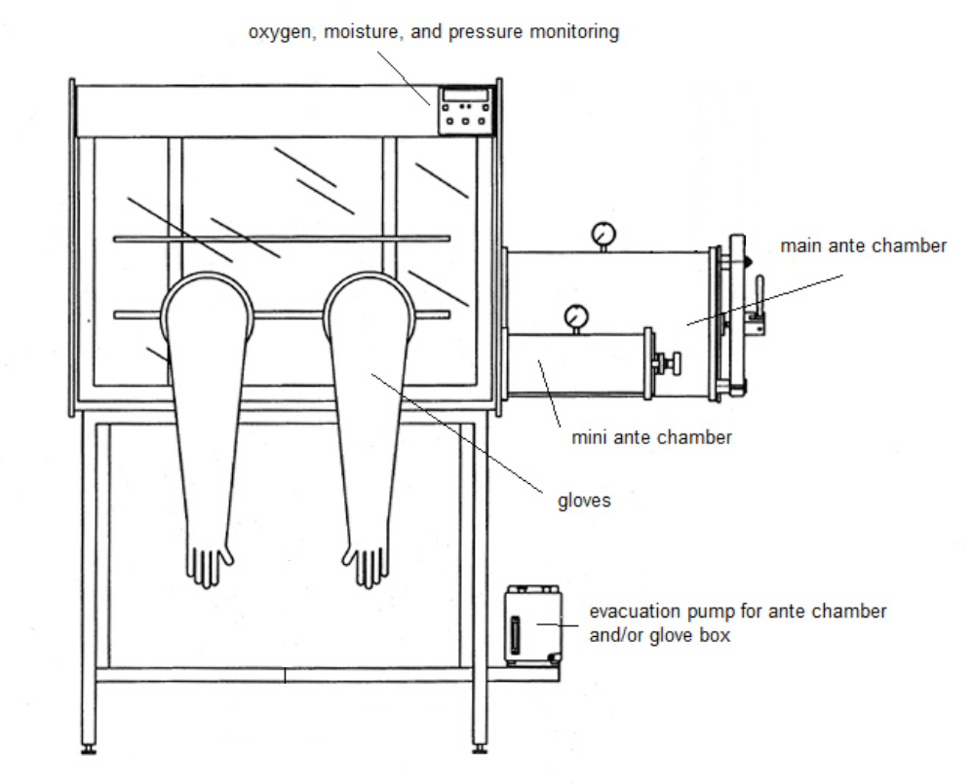
Figure 1. General schematic of a glovebox

