Overview

Source: Robert M Rioux, Ajay Sathe, Zhifeng Chen, Pennsylvania State University, University Park, PA

The use of reagents sensitive to oxidation or moisture necessitates the use of air-free techniques. A Schlenk line is a routinely used glass apparatus to perform air and moisture free manipulations in a chemical laboratory¹. The Schlenk line is widely utilized by many chemists since it allows them conduct air or water sensitive reactions even without the expense and restriction of a glove box. The Schlenk line can be configured to inert gas atmosphere such as Nitrogen and Argon or expose the glassware to vacuum. Another way to achieve an air and moisture free environment involves the use of a glovebox. The major difference between a Schlenk line and a glove box is that purge and refill applies directly to the reaction vessels, whereas purge and refill applies to the airlock instead of the glovebox. Besides, in a glovebox, conventional laboratory equipment can be set up with a large inert space, however gloves have to be used to handle the experiment and the glovebox itself is also expensive.

Principles

A Schlenk line consists of two glass tubes connected using several ports. One of the tubes is connected to a source of vacuum, and the other is connected to an inert gas (typically nitrogen, but other inert gases can be used). The ports connecting the two tubes are equipped with two way valves which allow for the selection of either vacuum or inert gas atmosphere at the port outlet. A liquid seal is used at the end of the inert gas tube, to maintain the inert atmosphere in the event of backflow while refilling evacuated glassware.

Procedure

- General procedure for carrying out a reaction under an inert atmosphere

  - Evacuating the glassware

    - Start the vacuum pump and fill the dewar flask in which the schlenk line trap is immersed in with liquid nitrogen.

    - Use oven dried or flame dried glassware to ensure that there is no residual moisture adsorbed on the walls of the glassware.

    - Seal the flask using either ground glass adapters, or rubber septa. It is highly recommended that vacuum grease is used to avoid seizing of the ground glass joints.

    - Connect the sealed glassware to the Schlenk line using an appropriate adapter/connection.
    - Turn the two-way valve to open the line to vacuum.

    - Evacuate the system and let the flask cool to room temperature

  - Purging with inert gas

    - Make sure the inert gas line is open and sufficient flow is seen through the bubbler. A typical flow for operation of the schlenk line is about one bubble per second. The flow should be increased while initially purging the system after evacuation.

    - Once the flask has cooled to room temperature, turn the two-way valve slowly to open the line to inert gas, taking care that some gas still manages to reach the bubbler. Use caution to not change over to inert gas too quickly, as this can lead to the liquid sealant from the bubbler to flow back into the schlenk line.

    - Once the inert gas flow has stabilized back to its original state (as observed on the bubbler), switch the two-way valve back to vacuum, and repeat the above procedure two more times.

  - Adding reagents

    - Once the flask has been evacuated and backfilled with inert gas a total of three times, it is now ready for use in handling air/moisture sensitive reagents. The inert gas flow can be readjusted to one bubble per second to save the consumption of inert gas.

    - The reagents are typically added from a septum sealed bottle or from a solvent dispensing station.

    - Use an oven dried cannula or needles to transfer air sensitive reagents into the flask. Make sure the flask is under an inert atmosphere, and not under vacuum as addition of chemicals to a flask under vacuum can damage the vacuum source.

  - Quenching the reaction

    - Once the reaction is complete, carefully quench the reaction using an appropriate reagent.

    - The quenching step regularly results in the generation of gases, make sure that the two-way valve is open to the inert gas so that there is no pressure build-up in the glassware.

- Basic design and set up of Schlenk line.
The design of Schlenk lines varies from lab to lab but the key features are the same. Figure 1 shows a schematic set up of the Schlenk line with key features pointed out.
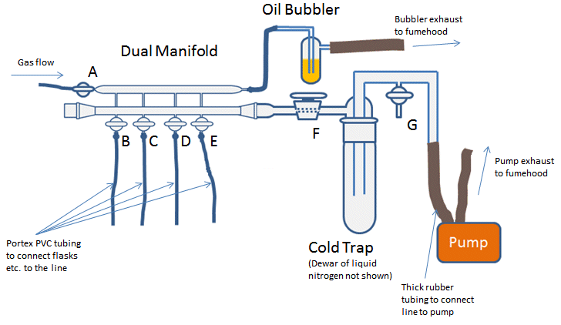

Figure 1. Schematic set up of a Schlenk line.

The dual manifold consists of two parallel glass tubes, which form the main body of Schlenk line. A gas manifold is connected to the inert gas supply and a vacuum manifold is connected to the vacuum line, which allows switching between inert gas and vacuum by tuning the taps. The gas exits the manifold through a visible oil bubbler in order to monitor the flow of the gas. The vacuum manifold is closed at one end and the other end is connected to a cold trap and a vacuum pump. The cold trap is used to prevent volatile or corrosive solvents from damaging the pump.
- Safety concerns with Schlenk line.

3.1 Liquid oxygen.
Liquid oxygen can accumulate if a constant steam of air goes into the vacuum line with the cold trap. This can be indicated by a light blue liquid in the trap, since liquid oxygen is light blue. Liquid oxygen is dangerous due to its violent reaction with organic solvents, including the vacuum grease and the high pressure generated once vaporization occurs in this confined space. Remember to never open the vacuum line to air when the cold trap is in place.

3.2 Explosion.

3.2.1 Pressurized gases can become dangerous, so make sure the system is open with the inert gas flowing. Explosions can occur if pressure is built up in the case of a closed system.

3.2.2 Violent reactions: If the reaction gets out of control, a large volume of gas might be generated quickly and may cause an explosion. Be aware of the reaction before operating in the Schlenk line.

3.2.3 Heating a closed system: In a closed system, the increase of the temperature will increase the pressure also. Be aware of any reactions with thermal properties and make sure the line is open and there is a bubbler for pressure relief.
3.3 Implosion.
Cracks in the glassware will cause breaks under vacuum. Repair or replace cracked glassware.

Summary
The Schlenk line is an extremely useful system, allowing the manipulation of air- and/or water-sensitive reagents without the expense and restriction of a glove box. It is most safely utilized inside a working fume hood. Care should be taken to prevent pressure build-up in the schlenk line by ensuring proper ventilation through a gas bubbler.

References:
- Shriver, D. F.; Drezdzon, M. A. The Manipulations of Air-Sensitive Compounds, 2nd ed.; Wiley: New York, 1986.
- Tips and Tricks for the Lab: Air-Sensitive Techniques, Sarah Millar, 2013, ChemistryViews at
http://www.chemistryviews.org/details/education/3728881/Tips_and_Tricks_for_the_Lab_Air-Sensitive_Techniques_1.html

