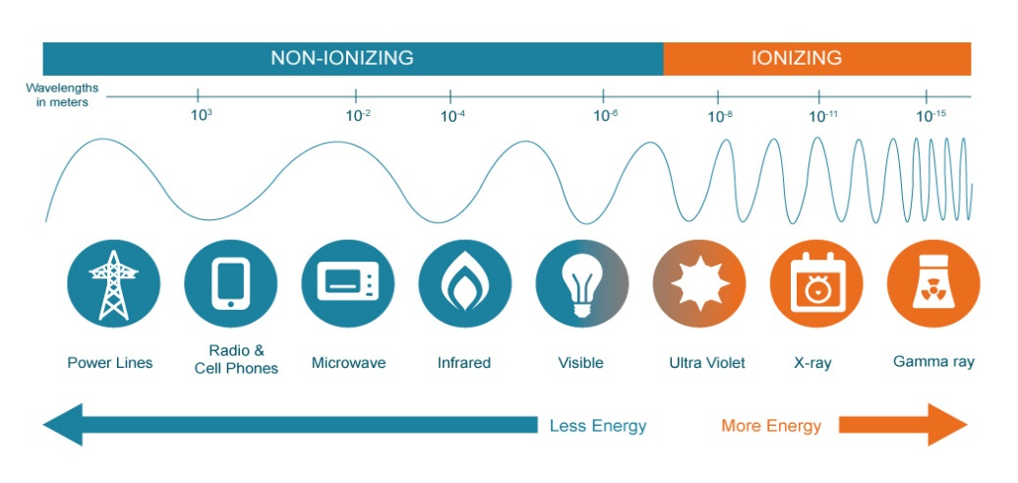
Fig. 1.

Table 2. List of permissible dose limits for radiation workers⁴
Radiation Workers (Users)​ | Maximum Permissible Dose  (mrem)​ | 10% CU Notification  Limit  (mrem)​ | 25% CU ALARA  Investigation (mrem)​
Whole body (WB) total effective dose equivalent (TEDE) from internal (CEDE) and external (DDE) sources​ | ​5,000/year | ​500/year | ​1,250/year
Total organ dose equivalent (TODE) from internal (CDE) and external (DDE) sources | ​50,000/year | 5,000/year​ | 12,500/year​
Lens of the eye dose equivalent (LDE)​ | ​15,000/year | ​1.500/year | ​3,750/year
​Skin, hands, forearms, elbows, knees, leg below the knee, feet and ankles shallow dose equivalents (SDE)​ | 50,000/year​ | ​5,000/year | 12,500/year​
​Embryo/foetus​ | ​500/gestation period for a declared pregnancy | ​50/gestation period | ​125/gestation period
Non-radiation workers (non-users), including members of the public​ | ​100/year | ​100/year | 100/year

ALARA: as low as reasonably achievable
mrem: milli roentgen equivalent in man (or mammal), CGS unit of equivalent dose

