Figure 1:
Type of flame | Gas tap | Air hole | Appearance | Properties
Yellow flame | Fully (or partly) open. | Closed | 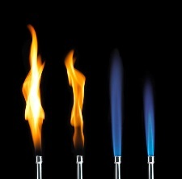 | Used to light the burner and when it is not heating anything. It is easy to see and will not readily set fire to clothing, etc. This flame is unsuitable for heating as it coats surfaces with soot (carbon).
Medium flame | Fully (or partly) open | Partially closed | 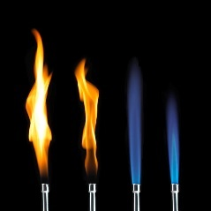 | Used for general heating at medium temperature. Sometimes it might difficult to see the flame in bright sunlight.
Roaring flame | Fully open. | Fully open | 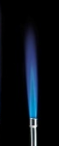 | For very strong heating (which is not very often). The hottest section of the flame is just above the blue cone of unburnt gas.

Figure 2

