PI Name: Robert M. Rioux & Zhifeng Chen

Science Education Title: Electrical Safety

Overview
Among the many hazards that might be present in the laboratory, electrical hazards are one of the most common we must be cognizant of since most of the laboratory equipment we use requires electricity for operation. Improper handling or operation of electrical devices might lead to electric shock with the potential risk of injury or even death. Electric sparks can lead to fire or explosion (since many flammable chemicals may be stored nearby to electrified instrumentation). Therefore, knowledge regarding electrical safety and what to do in case of emergency is essential for the laboratory personnel. Precautions can be employed when working in the laboratory to avoid electric shock and electrical fire or explosion.

Principles
Precautions are always needed when working with electrical devices. Make sure all electrical devices and wires are in good condition before powering up. If you are unfamiliar with the proper examination of electrical devices, consult your departmental electronics personnel or seek assistance from a commercial electrician or electronics engineer. Prior to powering up any instrument regardless of power requirements, make sure the working environment is in proper condition. Ensure the supporting surface is sturdy enough to hold the electrical device and that the surface is free of debris, including any type of standing liquid. Ensure that flammables are kept at a proper distance and stored in an appropriate flammable gas cabinet. After powering up, make sure the electrical devices’ working environment remains free of clutter. Remove water and flammable and explosive chemicals from the area when they are not required for the experiment. Your employer will most likely have a plan of action in case of a fire (electrical or other source); be sure to follow this protocol. However, in the case of emergency, dial 911 first. If it is safe enough, remember to shut down the power before any further action.

Procedure:

- Preparation for Electrical Hazards

  - Be familiar with the location of the laboratory electric control panel and know how to shut down the power in case of emergency. Locate the circuit breaker box in the laboratory and identify the circuit in which the electrified equipment is plugged into. All circuit breakers should be labeled appropriately, identifying the laboratory area or specific equipment it is associated with.

  - Be familiar with the type and location(s) of fire extinguishers in case of an electrical fire. Electrical fires (also known as Class C fires) require an extinguisher containing carbon dioxide. The location of the fire extinguisher should be marked with overhead or floor signage with arrows pointing to the location. Here are 4 key steps for proper using extinguisher:
a. Pull the pin.
b. Aim the nozzle towards the base of the fire.
c. Squeeze the trigger to control the release of agent.
d. Sweep from side to side.

  - Inspect all laboratory electrical equipment periodically to ensure that all equipment and its associated internal and peripheral wires are in prime working conditions. If any wires are identified as in poor condition have them repaired or replaced by a qualified electrician. It may be advantageous to have group members assigned to this task with the results of their investigation provided in a log book associated with the instrument.
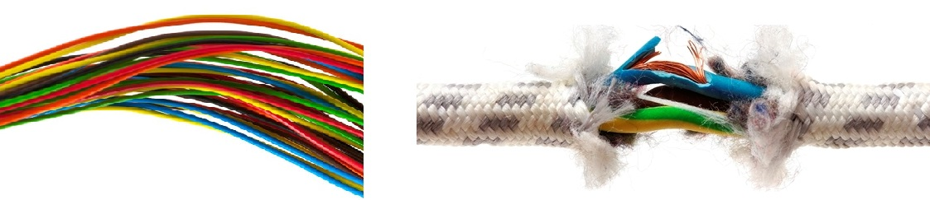

Wires in good condition Wires in bad condition

- Avoiding Electric Shock

  - Never touch electronics with wet hands or wet materials.

  - Check that all power cords are in good condition before turning power on. Frayed cords or exposed wires should not be used. Have the cord repaired or replaced by a qualified electrician.

  - Keep wires away from corrosive chemicals and organic solvents to avoid erosion of insulation on wires.

  - Replace damaged or broken sockets, plugs, and joints immediately to avoid further damage. Do not attempt to force a plug into a socket in which it does not fit.

  - Shut down the power and unplug the power cord before opening the cover to any electrical devices. Be aware that some capacitors may still be charged up even hours after removing the cover.

  - Only use equipment with grounding plug in the lab. The main plugs used for lab equipment include single-phase with safety ground, three-phase with safety ground, single-phase center tapped with safety ground and three-phase with neutral with safety ground. Do not ever force a plug into a socket. Verify that they are appropriate mates.

  - Never use extension cords for permanent lab equipment except for personal computers or temporary usage. Use surge protectors to protect electrical devices from voltage spikes. Avoid “daisy chaining” of extension cords.

  - Never take risk of repairing unknown electric issues. Ask qualified electrical workers to inspect or repair.

  - Never touch a person being electrically shocked because you will act as a conduit for the electricity to reach ground. Call 911 immediately. Ensure your safety first and then shut down the power if possible or use non-conductive material such as wood, glass, or rubber to pull the person away from the electric contact.

- Avoiding Electrical Fire or Explosion

  - Don’t overload a circuit. If overload, the actual power, current and voltage might exceed the rated value to cause fire. If you are unable to determine the rate values, consult with a person who can determine if the current circuit load exceeds the maximum recommended draws.

  - Store flammable and explosive chemicals away from electric devices. The sparks generated by electric devices might cause fire or an explosion with flammable and explosive chemicals nearby.

  - Make sure all electric devices are away from hot point sources (i.e., an open flame) to prevent melting and electrical fire.

  - In case of electrical fire, leave the area first and call 911 immediately. Pull the most convenient fire alarm and shut down the main power source if safe and possible. Never use water or a conductive foam extinguisher. Use sand or a carbon dioxide extinguisher instead.

Summary: Electrical devices are everywhere in the laboratory. It is essential to follow electrical safety principles to prevent electrical shock, electrical fire, or explosion. Be prepared about what steps should be taken in the case of emergency. Identify and mark the location of fire extinguishers in the laboratory. Be sure to use an extinguisher meant for a Class C fire. Always remember to be safe first and then shut down the power to any electrical malfunctioning electrical devices if it can be done in a safe manner.

References：

1. Electrical Safety in the Lab, 2009, Lab Manager. at

http://www.labmanager.com/lab-health-and-safety/2009/11/electrical-safety-in-the-lab?fw1pk=2#.V7DGYT4rJcw

2. Electrical Safety in the Laboratory, Environmental Health & Center, the University of Iowa. at
https://ehs.research.uiowa.edu/electrical-safety-laboratory

3. How to Use a Fire Extinguishe, 2013, Many Skills, Survival. at http://www.artofmanliness.com/2013/01/23/how-to-use-a-fire-extinguisher/

