
Figure 1: World Trade Center (NYC) transportation hub.

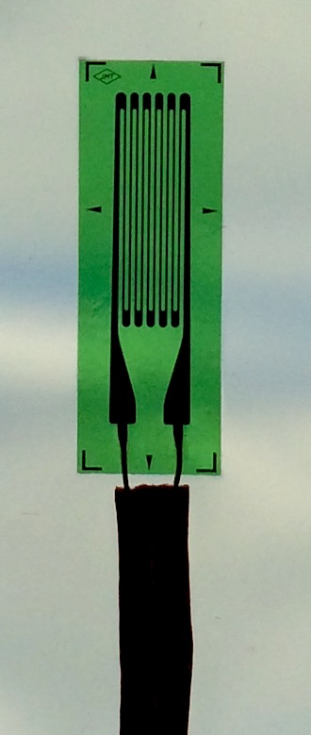

Figure 2: Strain gage.

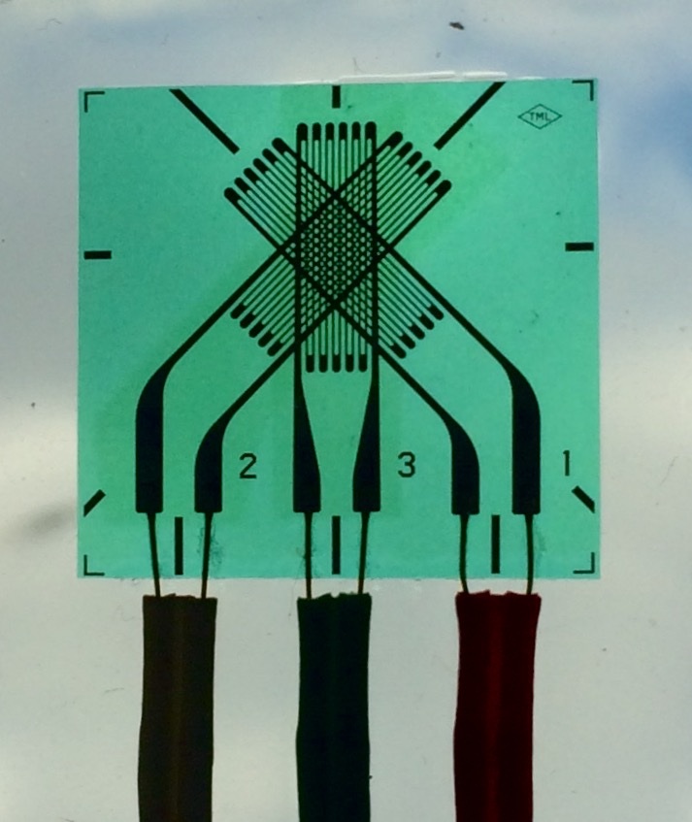

Figure 3: Rosette strain gage.

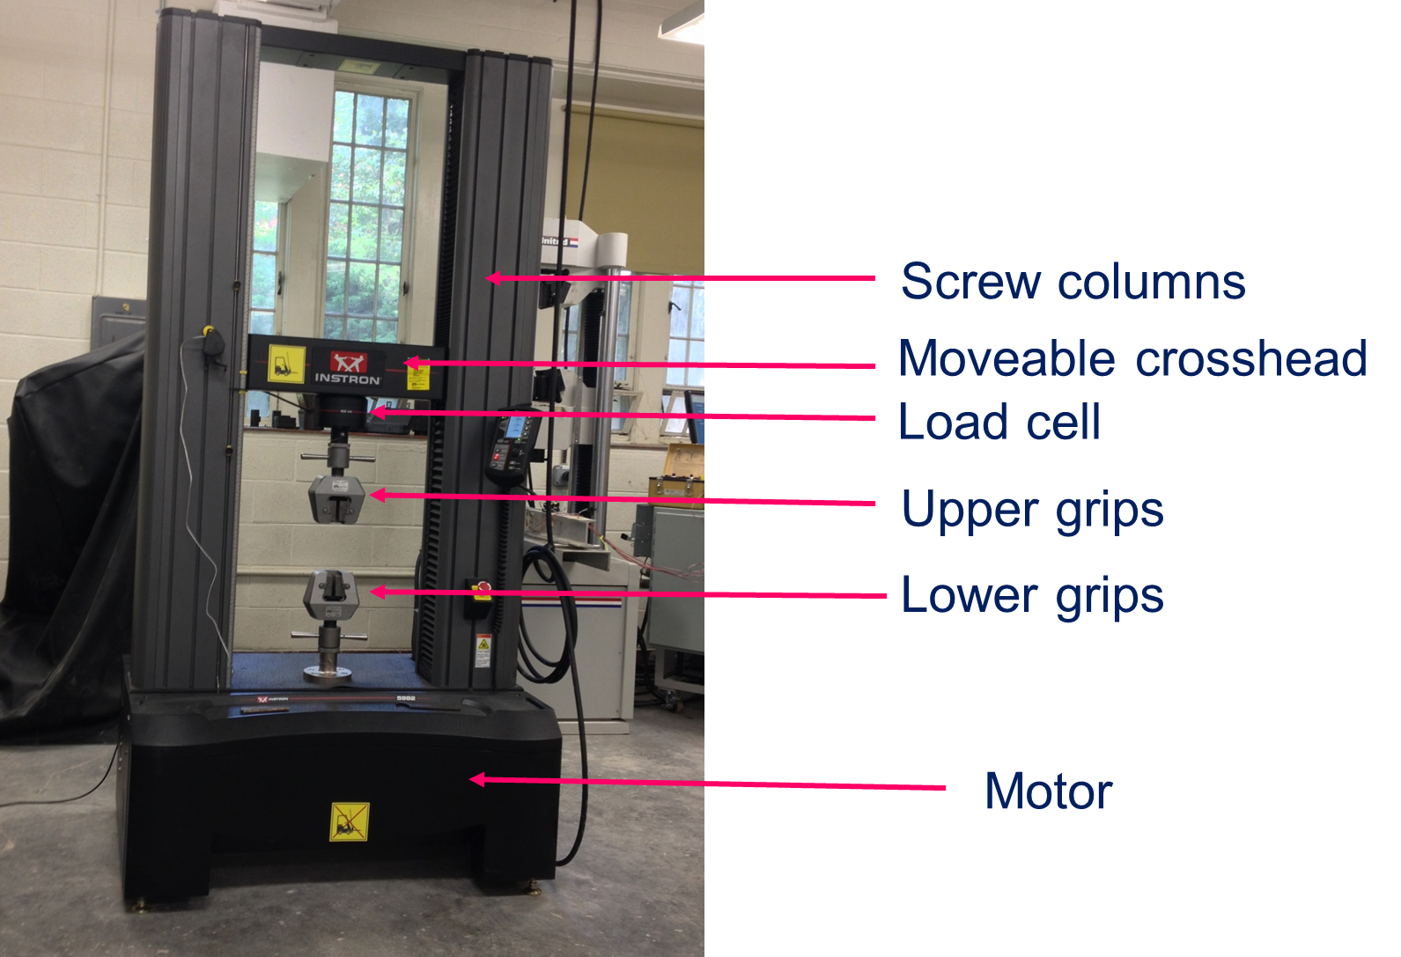

Figure 4: Universal testing machine.

Figure 5: Principal strain data showing the slope of the line between maximum and minimum principal strain, which corresponds to Poisson's ratio.

Figure 6: Physical significance of strain rosette readings shown on Mohr’s circle for strain.

Figure 7: Slope of line of maximum stress vs. maximum strain is Young’s modulus.

Figure 8: Mohr’s circle for plane stress for the case of a 7.34 lbs. load.

