
Figure 1 - World Trade Center (NYC) transportation hub (© RTLeon)

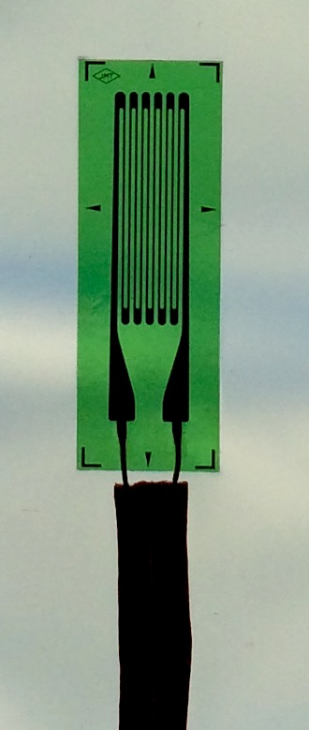

Figure 2 – Strain gage (crop as needed – see below)

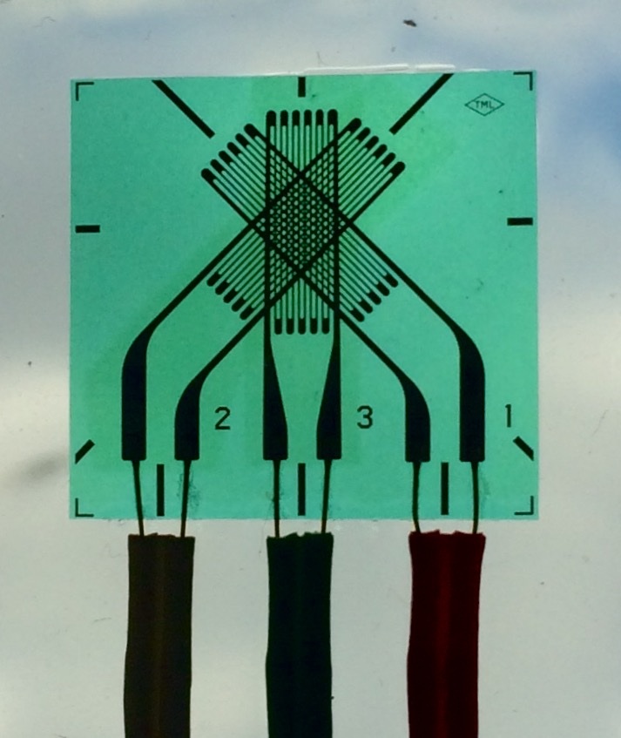

Figure 3 - Rosette strain gage (crop as needed – see below)

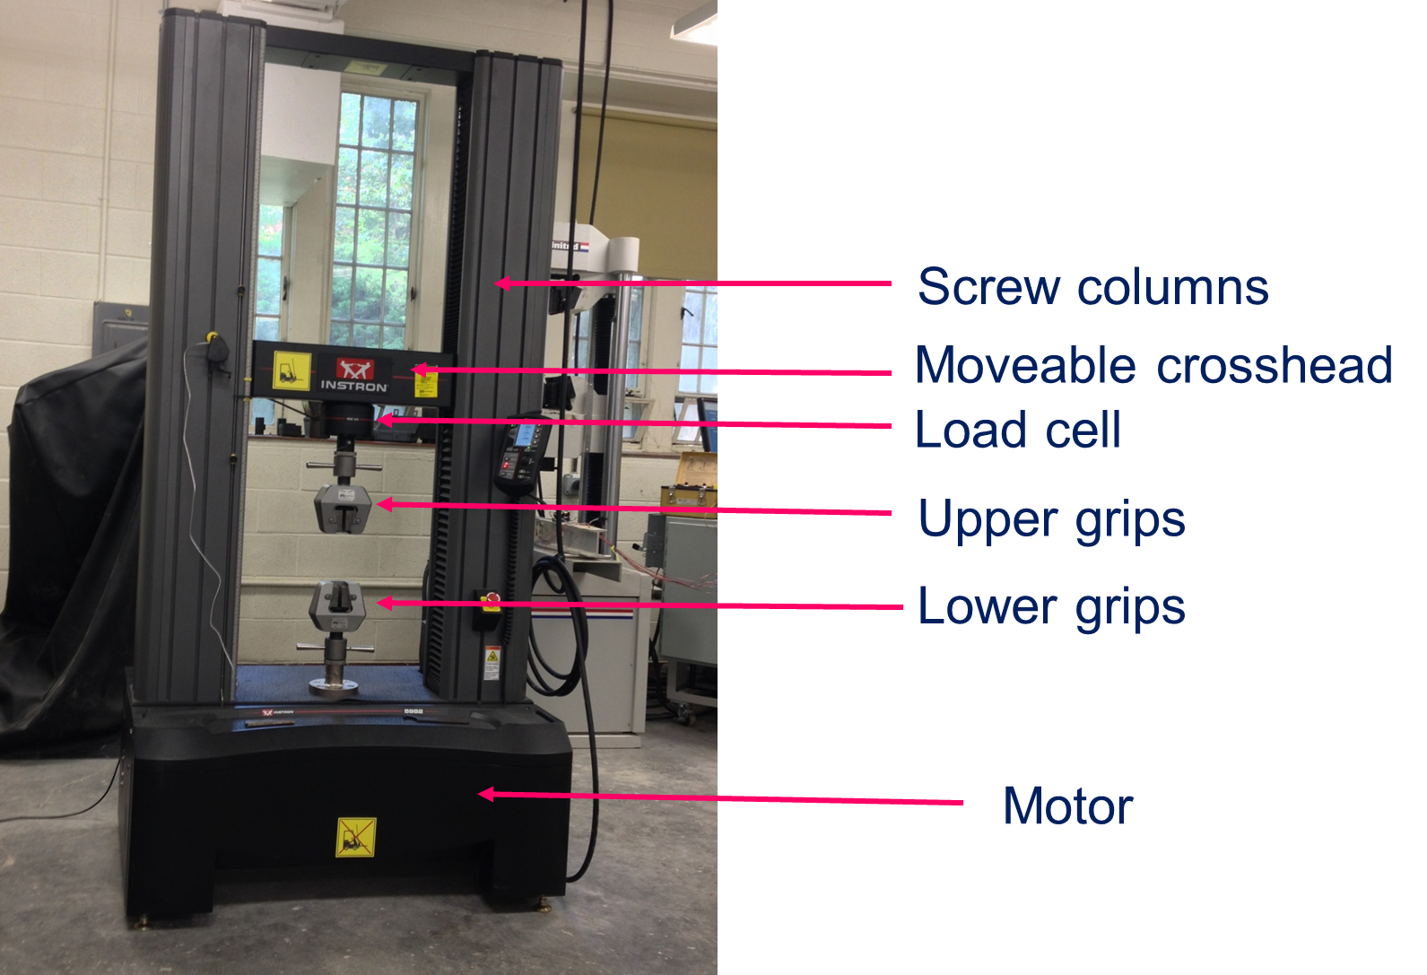

Figure 4

Figure 5
Figure 5 - Principal strain data showing the slope of the line between maximum and minimum principal strain, which corresponds to Poisson's ratio.

Figure 6 – Physical significance of strain rosette readings shown on Mohr’s circle for strain.

Figure 7 - Slope of line of maximum stress vs. maximum strain is Young’s modulus.

Figure 8 – Mohr’s circle for plane stress for the case of a 7.34 lbs load.

