Figure 1- Typical stress-strain curve for a heat treated aluminum

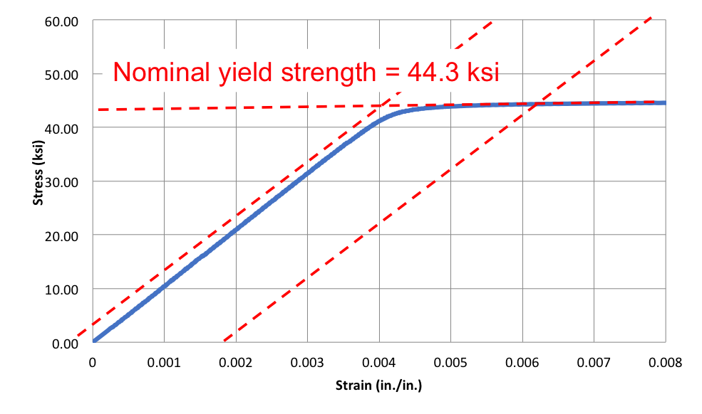

Figure 2 - Definition of yield strength for materials without an obvious yield point
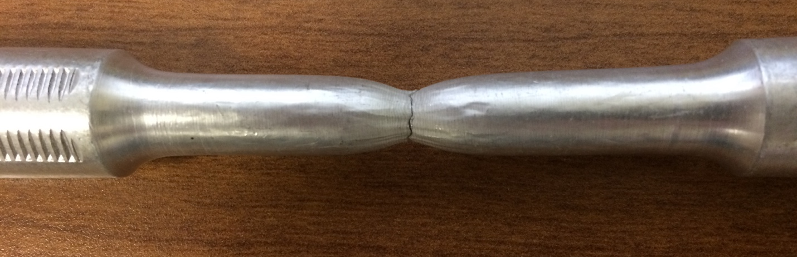
Figure 3 - Necking of aluminum specimen

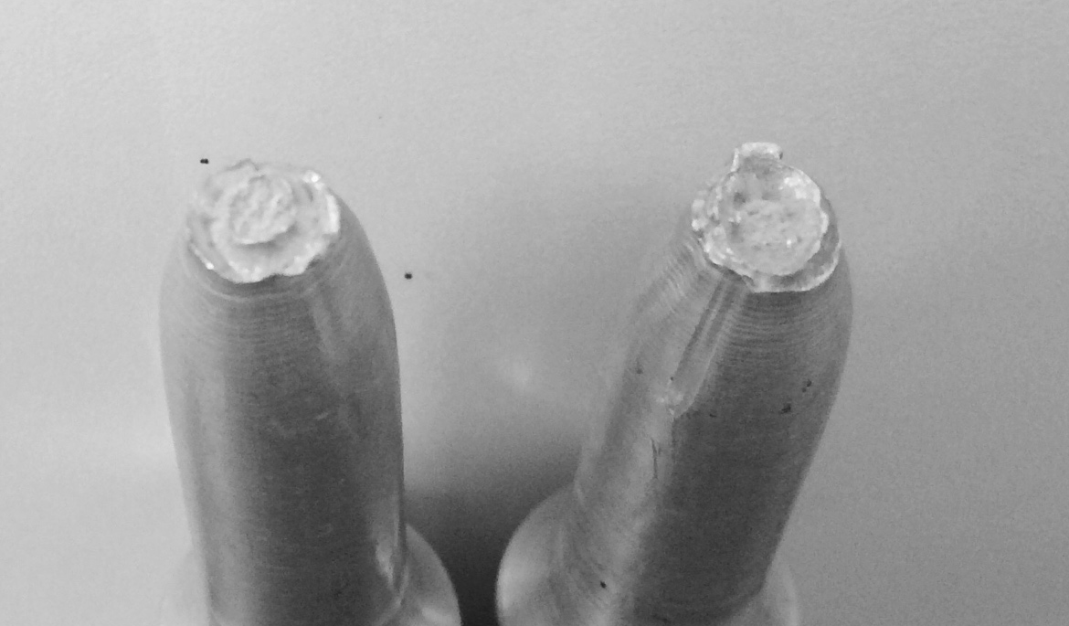
Figure 4 - Typical semi-ductile failure surface

