Figure 1 - Stress-strain curve for low carbon steel.

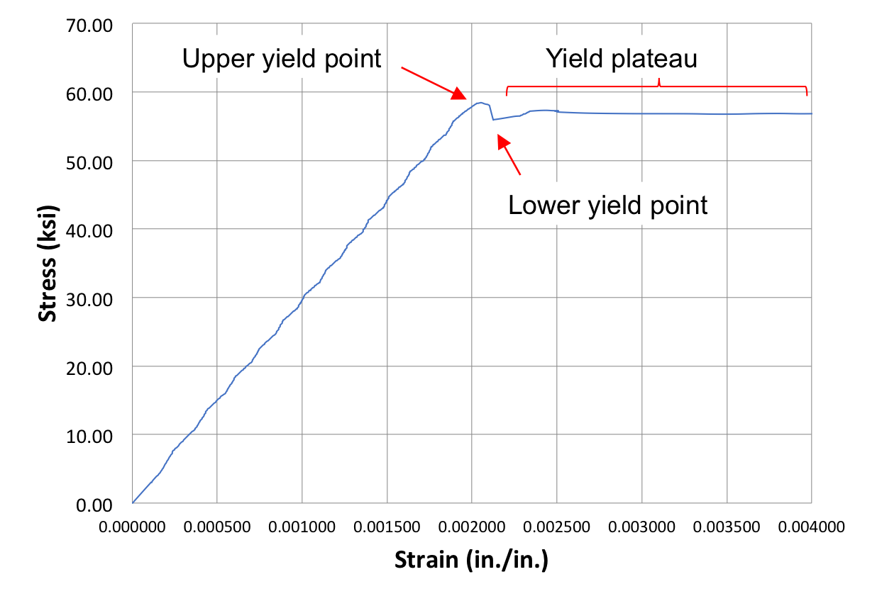

Figure 2 - Definitions of variables at low strains

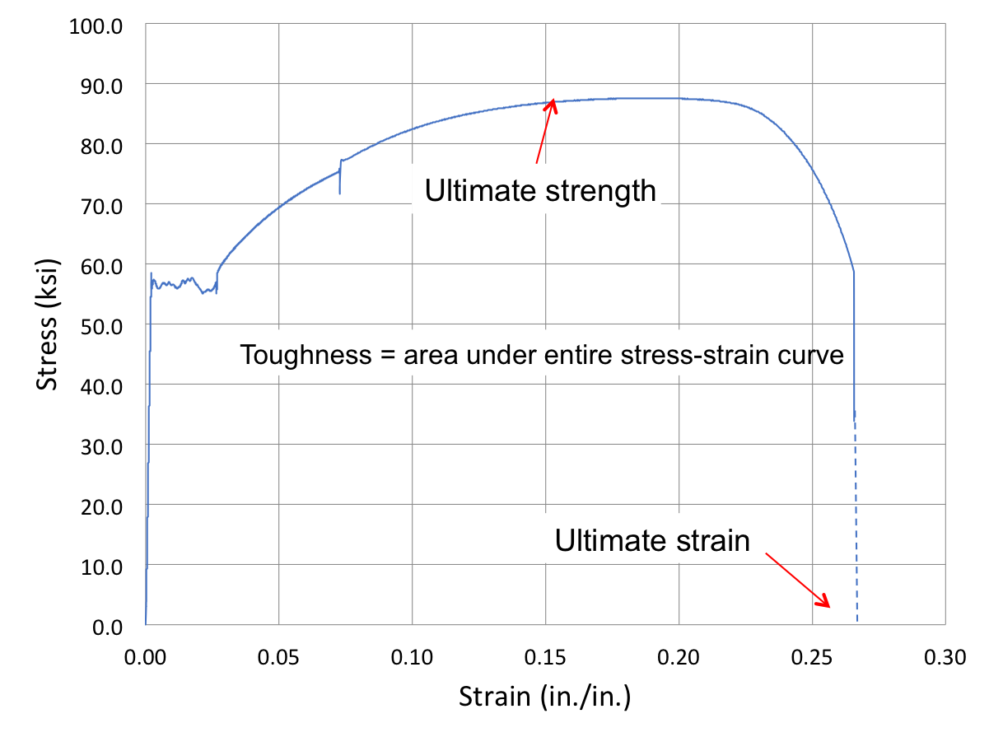

Figure 3 - Definitions at large strains

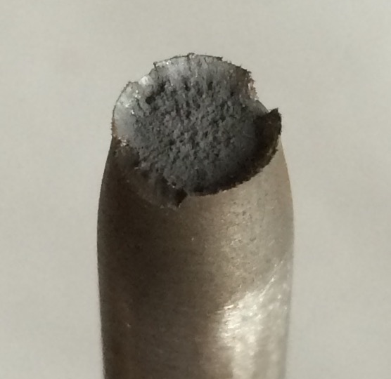 | 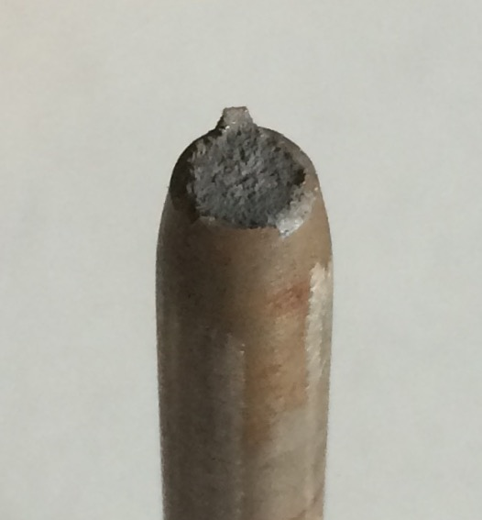
Figure 4 - Typical ductile (left) and brittle (right) failure surfaces

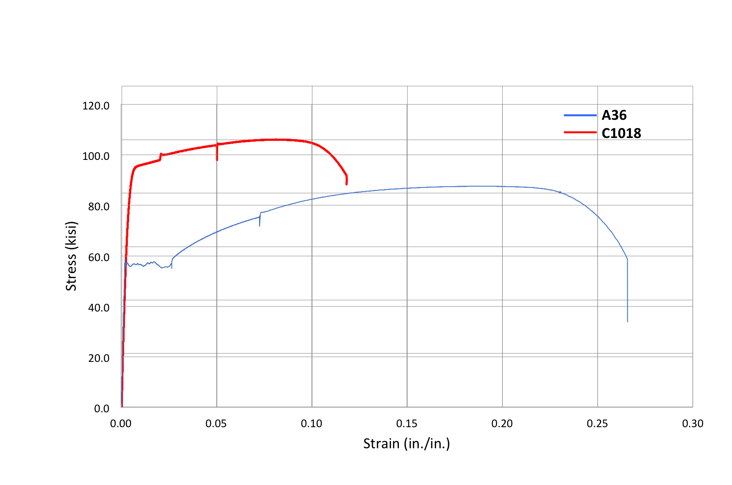

Figure 5 - Final stress-strain curves

