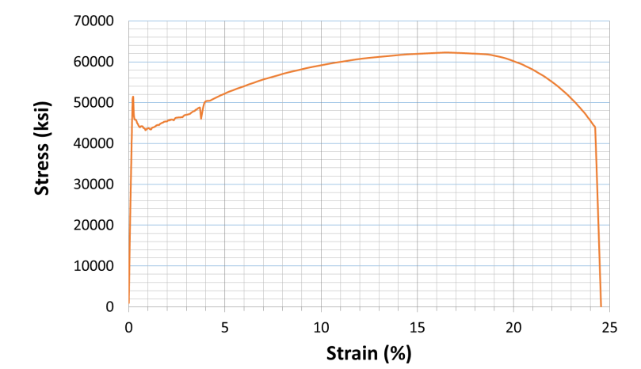
Figure 1 - Stress-strain curve for low carbon steel

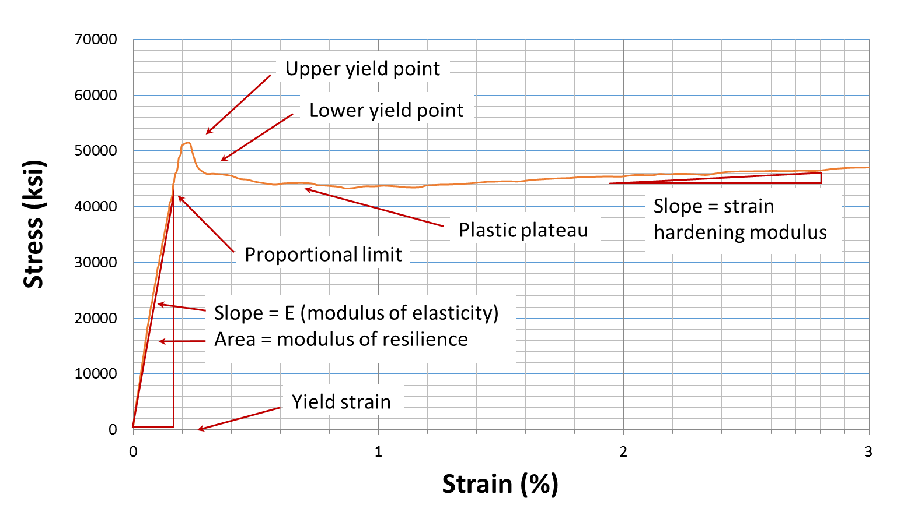
Figure 2 - Definitions of variables at low strains

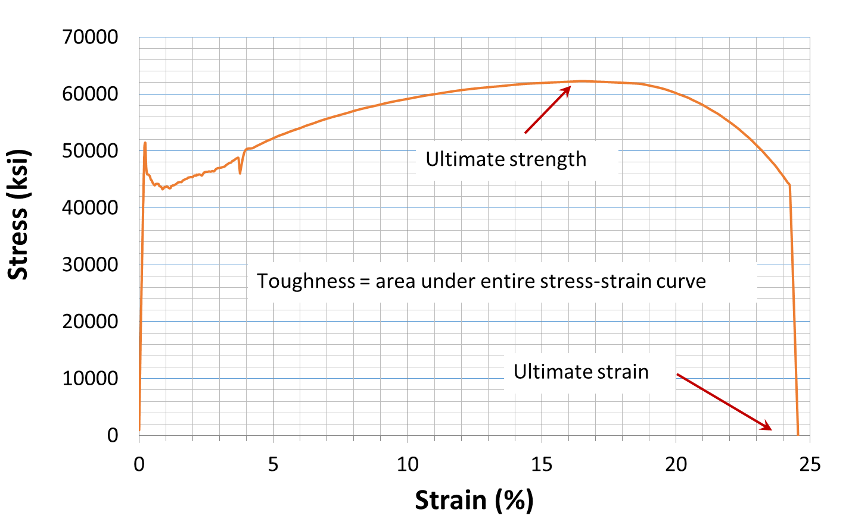
Figure 3 - Definitions at large strains

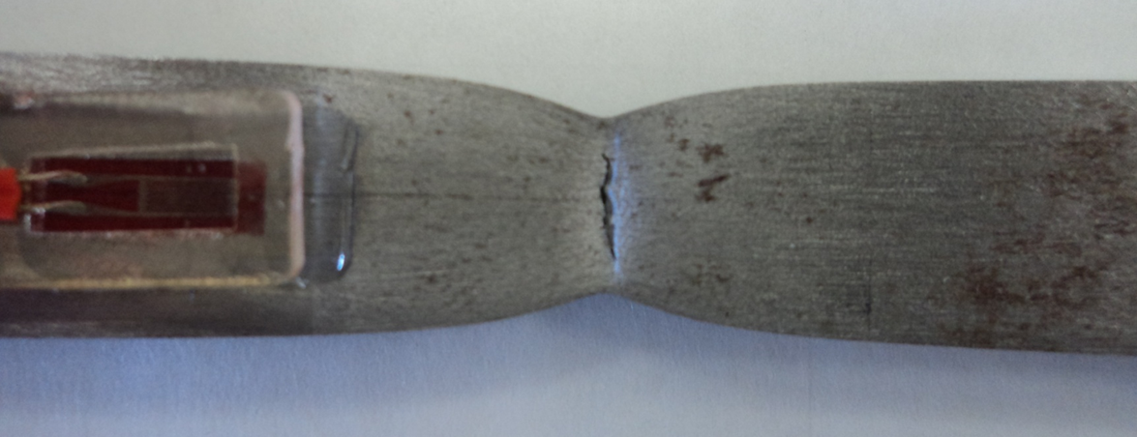
Figure 4 - Rectangular steel specimen just before failure. Note necking and beginning of fracture due to ductile cleavage

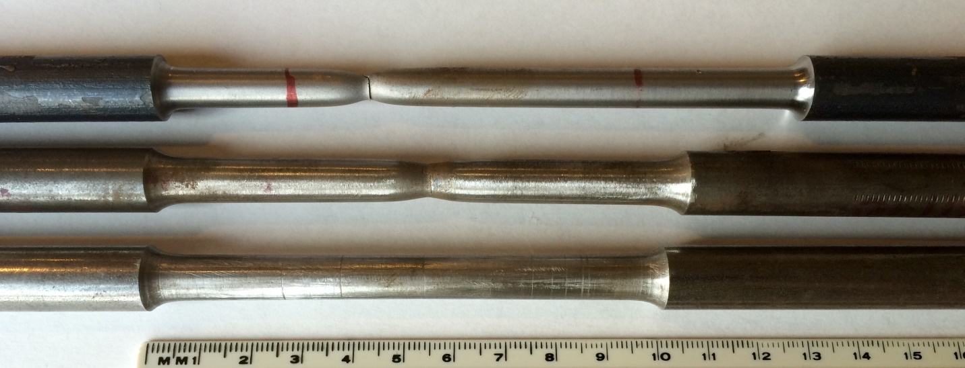
Figure 5 - Elongation at failure for A36 (top), 1040 (middle) and untested specimen (bottom)

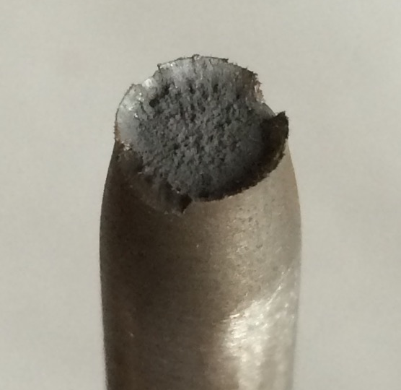 | 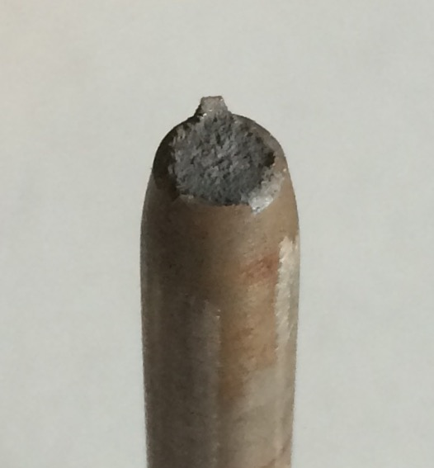
Figure 6 - Typical ductile and brittle failure surfaces

Figure 7 - Final stress-strain curve

