Overview

Source: Vy M. Dong and Daniel Kim, Department of Chemistry, University of California, Irvine, CA
Controlling the reactivity and selectivity during the synthesis of a molecule is very important criteria for chemists. This has led to the development of many reagents that allow chemists to pick and choose reagents suitable for a given task. Quite often, a balance between reactivity and selectivity needs to be achieved. This experiment will use IR spectroscopy to monitor the reaction and to understand the reactivity of carbonyl compounds as well as the reactivity of hydride-reducing reagents.

Principles
Before understanding hydride-donor reagents, the reactivity of carbonyl compounds needs to be understood. Carbonyl compounds have a slight positive charge on the carbonyl-carbon giving it an electrophilic-character. Thus, carbonyl compounds that have a positive charge are more reactive to different nucleophiles such as a hydride donor. Acyl chlorides have a good leaving group (Cl–) making it also very electrophilic. Esters and amides are more stable because of the strong resonance structure from the second heteroatom on the carbonyl.

Most reductions of carbonyl compounds are done with reagents that transfer a hydride from boron or aluminum. Two common reagents of this type are sodium borohydride and lithium aluminum hydride. Sodium borohydride is a less reactive donor reagent but is efficient for reducing aldehydes and ketones to alcohols. However, lithium aluminum hydride is much more reactive and can reduce ketones and aldehydes to alcohols but also reduce esters, amides, and carboxylic acids.

To demonstrate the varying degree in reactivity, a reaction with two carbonyl functional groups will be subjected to two sets of conditions with hydride-donating reducing reagents.

Procedure
1. Measuring Properties of Ethyl Acetoacetate

- Take an IR of the starting material (ethyl acetoacetate).

- Take a TLC using 40% ethyl acetate in 60% hexanes.

2. Reduction of Ethyl Acetoacetate with Sodium Borohydride

- Add 1 mmol of ethyl acetoacetate to a round-bottom flask.

- Add 5 mL of ethanol and swirl to mix completely.

- Lower the beaker into an ice-water bath.

- Weigh 1 mmol of sodium borohydride and slowly add to the stirred solution of ethyl acetoacetate.

  - Add in small portions. The reaction is exothermic and bubbles vigorously.

- Immediately after, monitor the reaction by TLC every few minutes until the reaction is complete.

- Once complete, add 10 mL of water to the reaction mixture.

- Transfer into a separatory funnel and extract with ethyl acetate (2x 30 mL).

- Dry with DI water (1x 30 mL) and with brine (1x 30 mL).

- Dry over sodium sulfate and filter into a round-bottom flask.

- Evaporate the solvent on a rotary evaporator.

- Take a TLC and IR of the reduction product.

3. Reduction of Ethyl Acetoacetate with Lithium Aluminum Hydride

- Add 1 mmol of lithium aluminum hydride into a dry round-bottom flask and cap it with a septum.

- Purge the flask with nitrogen gas using a nitrogen inlet line. Make sure to have an exit valve.

- Add 10 mL of dry THF.

- Place the round-bottom flask into an ice bath.

- Make a solution of 1 mmol of ethyl acetoacetate into 3 mL of dry THF and slowly add dropwise into the reaction flask.

- The reaction will vigorously bubble until all of the reagent is added.

- Immediately after, monitor the reaction by TLC every few minutes until the reaction is complete.

- Once complete, add 1 M HCl dropwise. The reaction will bubble vigorously until all of the LiAlH₄ is consumed.

- Once consumed (no more bubbling), the septum can be removed and diluted with ethyl acetate (40 mL) and 1 M HCl (20 mL).

- Transfer to a separatory funnel.

- Extract with ethyl acetate (3x 50 mL).

- Dry with brine (1x 50 mL).

- Dry over sodium sulfate and filter into a round-bottom flask.

- Evaporate the solvent on a rotary evaporator.

- Take a TLC and IR of the reduction product.

Results

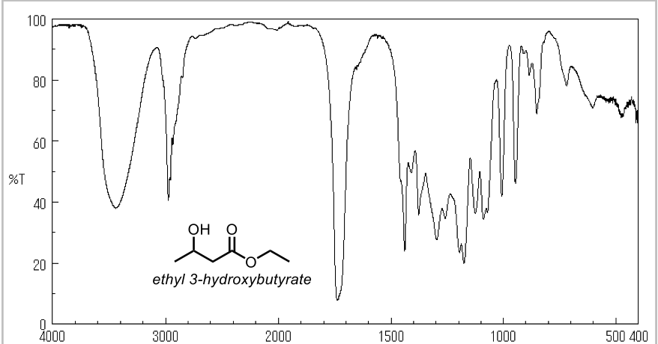

Figure 1. Representative IR results for ethyl 3-hydroxybutyrate.

Applications and Summary

The trends of carbonyl reactivity and hydride donor ability have been reviewed and demonstrated. The visual reactiveness of the two commonly used reagents is apparent and can be appreciated.
The understanding of the reactivity of reagents and functional groups is of high importance when developing new methods for reductions or any other kind of reaction. Controlling the selectivity and reactivity of any reaction is an important factor to consider when deciding on the reagents used for a chemical step. This drives chemists to develop new reagents and new methods.

The review of periodic trends is still important in organic chemistry. For example, when adding potassium metal to water, there is a more violent explosion than when sodium metal is added to water. For that reason, we could extend this analogy to the comparison and reasoning to why LiAlH₄ is more reactive than NaBH₄.

On the entire spectrum of nucleophiles and electrophiles, reactivity matters. A weak nucleophile will not react with a weak electrophile; but a more reactive electrophile might react with the same weak nucleophile. It all depends on their reactivity and the conditions.

