JoVE Science Education Series: Physics II

Title: Electric Potential

Overview

Source: Yong P. Chen, PhD, Department of Physics & Astronomy, College of Science, Purdue University, West Lafayette, IN

Electric potential, also known as “voltage”, measures the electric potential energy per unit charge. Electric field is a scalar quantity and is fundamental to many electrical effects. Like potential energy, what is physically meaningful is the difference in the electric potential. For example, the spatial variation in the electric potential is related to the electric field, which gives rise to the electric force on a charge. The difference in the electric potential between two points in a resistor drives the electric current flow.

This experiment will use both a volt meter and a fluorescent tube to demonstrate the electric potential (more accurately, the potential difference between two points in space) generated by a charged sphere and between two charged plates. The experiment will demonstrate the concept of equipotential surfaces, which are perpendicular to the electric fields.

Principles

A point charge Q located at the origin (r = 0) produces an electric potential:

$V=\frac{\left(\frac{1}{4}πεε_{0}\right)Q}{r}$ (Equation 1)

at any point in the space with a distance r from the charge (at origin r = 0). Equation 1 also describes the electric potential produced by a uniformly charged sphere (centered at r = 0) with total charge Q in the space outside the sphere (Figure 1). In both cases, the “reference” point (where the potential is zero) is at the infinite distance away from the charge. The electric potential varies along the radial direction, which is the direction of the electric field.

For two points P₁ and P₂ with distance r₁ and r₂ away from the origin (center of the charge), respectively, the potential difference between these two points is:

$V_{1}-V_{2}=\left(\frac{1}{4}πεε_{0}\right)Q(\frac{1}{r_{1}}-\frac{1}{r_{2}})$ (Equation 2)

If point P₂ is at infinity (→∞), this reduces Equation 2 to Equation 1. Therefore, there is a potential difference between two points if and only if these two points have a different distance away from the origin (center of the charge). A spherical surface centered at the origin is an “equipotential surface” in this case. Note in this case, the electric field (along the radial direction) is perpendicular to the equipotential surface (sphere). This turns out to be generally true: the equipotential surface is perpendicular to the direction of electric field.

As mentioned above, an electric field is closely related to the electric potential. An electric field would produce a potential drop (or “voltage drop”) along the direction of the field. Conversely, a convenient way to generate an electric field is to apply a potential difference. If two different voltages are applied between two separated parallel plate conductors (a setup also known as a parallel-plate capacitor; see Figure 2), with 0 V on the left plate (located at x = 0, and chosen as the reference point or “ground” in this case) and V₀ on right plate (located at x = d, where d is the separation between the two plates), then a uniform electric field is generated in the space between the two plates:

$E=\frac{V_{0}}{d}$ (Equation 3)

and in the direction from the higher voltage plate (which would be the right plate assuming V₀ is positive) to the lower voltage conductor. For an arbitrary point located at distance x from the left plate, its electric potential (equivalently, the potential difference between this point and the “reference” zero potential at the left plate) would be:

$V=V-0=Ex=\left(\frac{x}{d}\right)V_{0}$ (Equation 4)

In this case, the equipotential surfaces are planes with constant x—parallel to the plate and perpendicular to the direction of the electric field.

A metallic object under static situation (meaning that no charges are moving) is also an equipotential: that is, any two points on or within the metal should have the same potential (otherwise the potential difference would cause the free charge carriers in the metal to move). This principle underlies how a voltmeter is typically used to measure a potential difference. A voltmeter measures the electric potential difference between its two terminals:

$$V=V_{+}-V_{-}$$

If the two terminals are connected to two points (in space or in a circuit), A and B, respectively, using good metallic wires (such as V₊ = V_{A}, V₋ = V_{B}, because each metallic wire is an equipotential) as shown for example in Figures 1 and 2, then the voltmeter also measures the potential difference between these two points as:

$$V=V_{+}-V_{-}=V_{A}-V_{B}$$

This experiment will also use a fluorescence tube to visualize the potential difference at its two ends. A fluorescence tube is a device which lights up when there is a sufficient potential difference across its two ends (because the potential difference causes ionization and glowing of the gas medium in the tube). The higher the potential difference, then the brighter the glowing. If the potential difference between the two ends is zero or two small, the tube will not glow.

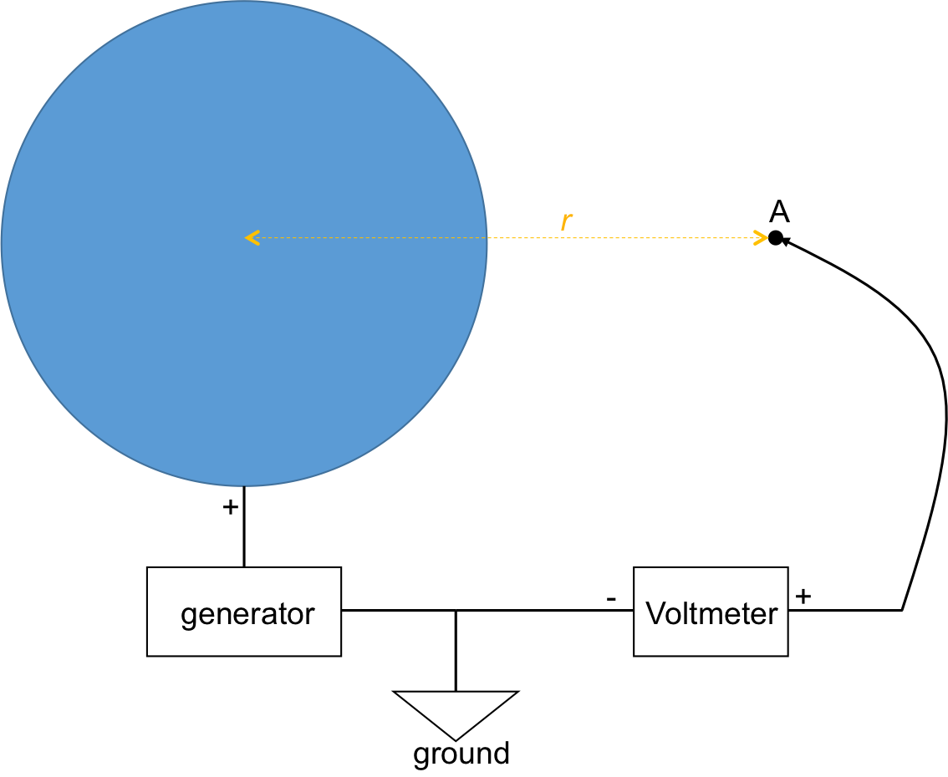

Figure 1: Diagram showing a charged sphere connected to an electric generator. A voltmeter is used to measure the electric potential at a point “A” (with distance r from the center of the sphere).

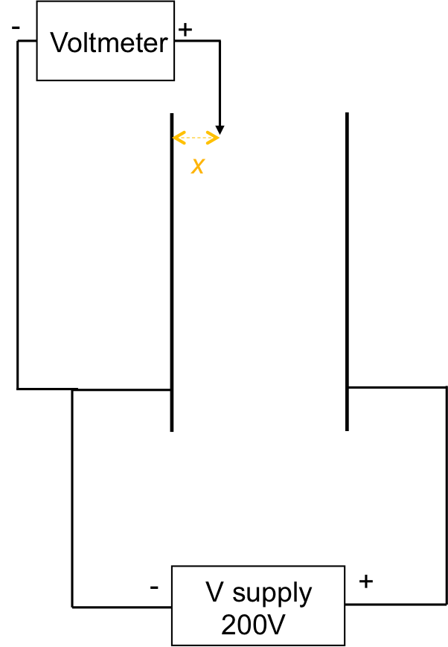

Figure 2: Diagram showing a parallel plate capacitor connected to a voltage supply (with 200 V difference between the two plates). A voltmeter is used to measure the electric potential at a point between the plates, with distance x from the left plate.

Procedure:

- Electric Potential Due to a Charged Sphere

  - Obtain a van der Graff generator, which can put charge on a metal sphere. The center of the sphere is defined as the origin for this experiment.

  - Obtain a voltmeter. Connect (using conducting cables) its “−” terminal to the ground or reference terminal on the van der Graff generator, or to an electrical ground (such as a large conducting pipe) far away (at least several meters) from the generator. Connect its “+” terminal to a voltmeter cable with a voltage probe tip that can be moved around. The schematic connection is shown in Figure 1.

  - Turn the crank of the generator by at least 10 turns to charge the sphere.

  - With the voltmeter turned on, place the tip of the voltage probe (connected to the “+” terminal of the voltmeter) about 0.5 m away from the origin. Use a ruler to measure or mark the distance beforehand, if desired. Record the voltage reading on the voltmeter. Move the tip around but maintain the distance away from the origin. Observe the voltmeter reading.

  - Repeat the above step with the voltage probe tip placed at about 1 m and 1.5 m, respectively.

  - Obtain a (hand held) fluorescence tube. Bring the tube to about 0.5 m away from the center of the charged sphere (Figure 3a). First, orient the tube so that it is along the radial direction away from the sphere. Observe the tube (turn off the lights to ease the observation in relative darkness). Then rotate the tube by 90 degrees so that it is perpendicular to the radial direction (Figure 3b). Observe the tube again.

- Electric Potential in a Parallel–plate Capacitor

  - Obtain a parallel plate capacitor, and set the separation between the two plates to be about 20 cm.

  - Obtain the voltmeter that was used step 1 above, and connect its “−” terminal to the left plate of the capacitor. Keep its “+” terminal connected to the voltage probe.

  - Obtain a DC voltage supply, connect the left plate of the capacitor to the “−” or reference terminal on the voltage supply, and connect the right plate to the “+” terminal of the supply.

  - Turn on the supply, and set the voltage to be 200 V.

  - Place the voltage probe (connected to the voltmeter) near the mid-point between the two plates (about 10 cm away from the left plate), as shown schematically in Figure 2. Observe the voltage reading. Move the probe tip around in a plane parallel to the plate such that it maintains the distance away from the left plate, and observe the voltage reading.

  - Repeat the step with the probe moved to about 5 cm and 15 cm, respectively away from the left plate.

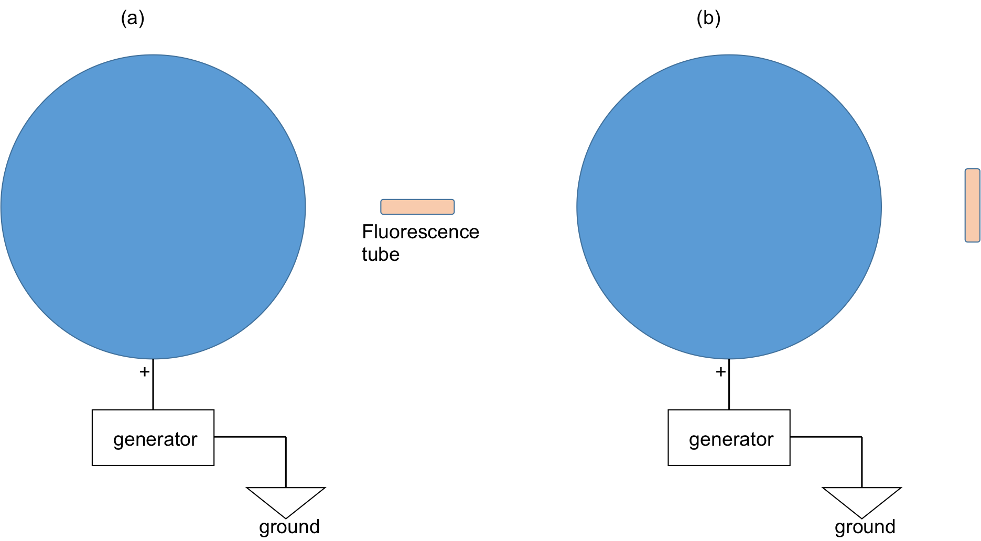

Figure 3: Diagram showing a charged sphere connected to an electric generator. A fluorescence tube is used to indicate the potential difference between the two ends of the tube. In the case of (a) the tube is oriented along the radial direction; and (b) the tube is oriented perpendicular to the radial direction.

Results

In steps 1.4–1.5, the voltmeter can be observed to give similar readings if the probe tip is kept at similar distances from the origin (that is, on an equipotential surface). However, the voltage drops if the probe moves farther away from the origin. The voltage reading at 1 m and 1.5 m away will be about 1/2 and 1/3 of the reading at 0.5 m away, respectively. If the voltage V measured versus the inverse distance (1/r) is plotted, a straight line results, as expected from Equation 1.

For steps 2.5–2.6, the voltmeter is observed to give similar readings if the probe tip is kept at similar distances from the left plate (again, on an equipotential surface). However, the voltage increases if the probe moves farther away from the left plate. Representative voltage readings at the three distances measured are listed in Table 1. If voltage V measured versus the distance x is plotted, a straight line results, as expected from Equation 4. Note the interesting contrasts with the previous case of the charged sphere (Section 1). In both cases a linear relation (straight line) is found—in the previous case (sphere), V is proportional to 1/r (inverse distance), whereas here V is proportional to distance x. This highlights that the spatial dependence of electric potential can be very different for different charge configurations.

Applications and Summary

In this experiment, we have measured the electric potential (relative to an appropriately chosen reference point) using a voltmeter for a charge, sphere as well as a parallel plate capacitor. We showed that the electric potential is linear in the inverse distance in the former case, but is linear in distance in the latter case. We also visualized the electric potential difference using a fluorescence tube oriented in various directions near a charged sphere.

Electric potential (voltage) is ubiquitous and perhaps the most commonly used quantity in electricity. It is often much more convenient to use electric potential (which is a scalar) than electric field (which is a vector), even though the two can be related to each other. Electric potential difference is used to drive and control charge motion (accelerate/decelerate/deflect charges), for example in a TV screen or electron microscope. Electric potential difference (what we usually call voltage) is also what drives current flow in a conductor. Whenever one measures a voltage, one is measuring the electric potential difference between two points (one of which is sometimes a reference point or ground defined to have zero potential).

