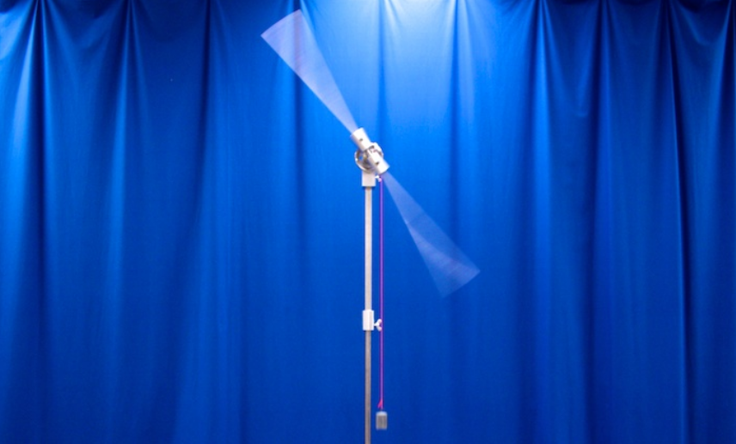
Figure 1

Procedure:

1. Measure the moment of inertia of the long rod.
  - Wind the string attached to the weight until the weight is very near the spinning arm.
  - Drop the weight and measure the time it takes to drop as well as the distance it drops.
  - Do 1.2 three times and calculate the average moment of inertia using equation 7.
  - Compute the theoretical moment of inertia of the spinning rod using the following formula $I = \frac{1}{12} M L^{2}$where $M$is the mass of the rod and $L$is the length.
  - Compare the theoretical value with the measured value and record answers.
2. Two masses attached to the rod
  - Place two 100 Kg masses 20 cm away from the center of the rod.
  - Repeat 1.2 and 1.3 with the attached masses.
  - The total moment of inertia should be equal to the moment of inertia of the attached masses plus the moment of inertia of the rod. Use this fact, the results from part 1 and equation 8 to determine the theoretical and experimental moments of inertia for the attached masses.
  - Compare the theoretical value with the measured value and record answers.
3. Effect of distance on moment of inertia
  - Repeat part 2 of the lab except move the attached masses to 10 cm away from the center of rotation. Notice any changes in the falling of the weight or the spinning of the rod.
  - Compare the theoretical value with the measured value and record answers.
4. Effect of mass on the moment of inertia
  - Repeat part 2 of the lab except change the mass size to 200 Kg.
  - Compare the theoretical value with the measured value and record answers.

Representative Results:

 | Theoretical Value  (Kg m^2) | Experimental Value  (Kg m^2) | Difference  (%)
Part 1
Part 2
Part 3
Part 4

Summary: In this experiment the moment of inertia for a rod and two masses were experimentally measured as well as theoretically calculated. The differences between these values were examined. The effect of mass on the moment of inertia was tested as well as the effect of distance from the axis of rotation.

Applications: Have you ever wondered why a tightrope walker carries that very long pole? The reason is that the long pole has a very large moment of inertia due to its length. Therefore it requires a large amount of torque to get it to rotate. This helps the tightrope walker to stay balanced as the pole will remain steady.

Wheels of cars and bicycles are never just solid disks instead they have spokes which support the wheel from the axle. This allows for a lighter design which aids in speed but the real reason for this design is rotational inertia. A solid disk has a larger moment of inertia than a hoop like shape. The smaller moment of inertia for the hoop makes spinning the wheel require less torque and perhaps more importantly it makes stopping spinning require less torque.

When a baseball player is at bat against a pitcher throwing fastballs they may want to speed up their swing in order to get a hit. This is done simply by moving their hands closer to the heavy end of the bat which is called “choking up.” This reduces the distance from the center of mass of the bat to the axis of rotation and therefore makes it easier for the batter to rotate the bat.

