PI NAME: Asantha Cooray
Science Education Title: Rotational Inertia
Overview: Inertia is the resistance of an object to being accelerated. In linear kinematics this concept is directly related to the mass of an object. The more massive an object the more force is required to accelerate that object. This is seen directly in Newton's second law which states that force is equal to mass times acceleration.
For rotation there is a similar concept called rotational inertia. In this case rotational inertia is the resistance of an object to being rotationally accelerated. Rotational inertia is dependent not only on mass but the distance that mass is from the center of rotation.
The goal of this experiment is to measure the rotational inertia of two masses rotating and to check the dependence of mass and distance from the axis of rotation.

Principles of Rotational Inertia: A certain object or system of objects has some rotational inertia. The rotational inertia about a certain axis is called the moment of inertia. Because the distance from the mass to the axis of rotation is important, a single object can have very different moments of inertia dependent on the axis about which it rotates. The moment of inertia for an object is defined as
$I = \sum{m_{i}} * r_{i}^{2}$(Equation 1)
For i number of objects.

In Equation 1 r is the distance from the axis of rotation to the mass. As can be seen in the equation, the moment of inertia is dependent on the mass of an object and the square of the distance from the mass to the axis of rotation.
Just like how linear kinematics has equations of motion rotational kinematics has analogous equations of motion. For example Newton's second law for linear motion is
$\vec{F} = m * \vec{a}$(Equation 2)
A similar rotational equation takes the form
$\vec{τ} = I * \vec{α}$(Equation 3)
Where$\vec{τ}$is the torque,$I$is the moment of inertia and$\vec{α}$is the angular acceleration. Here, the moment of inertia is the analog of the mass term in Newton's second law. Similarly the moment of inertia is present in the other important equations of rotational motion.
$Angularmomentum = \vec{L} = I * \vec{ω}$(Equation 4)
$Kineticenergy = \frac{1}{2}I * ω^{2}$(Equation 5)
Where $\vec{ω}$is the angular velocity of the object.
For this experiment, a mass is connected to a rotating arm by a string wound around the axis of rotation. See Figure 1 for an image of what the experiment looks like. Two masses will be connected to the rotating arm, friction will be ignored in this experiment and the total moment of inertia will be equal to the moment of the rotating masses plus the moment of the spinning arm.
The mass, which is falling under the influence of gravity, will enact a torque on the rotating arm. From equation 2$\vec{τ} = I * \vec{α}$but also$\vec{τ} = \vec{r} x \vec{F}$. Here$\vec{F}$is the force on the object, which comes from the tension$T$in the string and$\vec{r}$is the distance from the force to the axis of rotation. Here that distance is the distance from the edge of the wound string to the axis of rotation.
The angular acceleration$\vec{α}$is defined by$\vec{α} = \frac{\vec{r}}{\vec{a}}$where $\vec{a}$is the linear acceleration of a point on the wound string which corresponds to the acceleration of the falling weight. Putting everything together we have$I = \frac{{\vec{r}}^{2}T}{\vec{a}}$. To find the tension, we use Newton's second law. The sum of the forces on the object should be equal to the mass times the acceleration. Here the forces on the falling weight are gravity$m * \vec{g}$and the tension$T$so$m * \vec{a} = m * \vec{g} - T$. Assuming a constant acceleration, then $\vec{a} = 2\frac{d}{t^{2}}$where $d$is the distance the weight travels and $t$is the time it takes to fall that distance. This comes from the kinematic equations of motion.
Putting everything together results in an equation for the moment of inertia in terms of quantities that are measurable during the experiment.
$I = {\vec{r}}^{2}m\left(1 - \frac{t^{2}\vec{g}}{2}d\right)$(Equation 7)
If two masses are attached to the spinning arm at an equal distance$x$from the axis of rotation then the moment of inertia will be
$I = 2mx^{2}$(Equation 8)
which will be the theoretical value for the experiment.

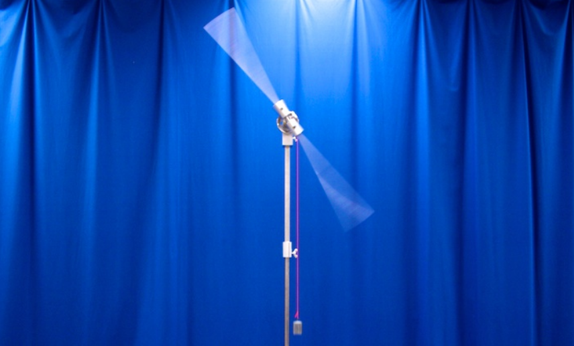
Figure 1

Procedure:

1. Measure the moment of inertia of the long rod.
  - Wind the string attached to the weight until the weight is very near the spinning arm.
  - Drop the weight and measure the time it takes to drop as well as the distance it drops.
  - Do 1.2 three times and calculate the average moment of inertia using Equation 7.
  - Compute the theoretical moment of inertia of the spinning rod using the following formula $I = \frac{1}{12} M L^{2}$where $M$is the mass of the rod and $L$is the length.
  - Compare the theoretical value with the measured value and record answers.
2. Two masses attached to the rod
  - Place two 100 kg masses 20 cm away from the center of the rod.
  - Repeat 1.2 and 1.3 with the attached masses.
  - The total moment of inertia should be equal to the moment of inertia of the attached masses plus the moment of inertia of the rod. Use this fact, the results from part 1 and Equation 8 to determine the theoretical and experimental moments of inertia for the attached masses.
  - Compare the theoretical value with the measured value and record answers.
3. Effect of distance on moment of inertia
  - Repeat part 2 of the lab except move the attached masses to 10 cm away from the center of rotation. Notice any changes in the falling of the weight or the spinning of the rod.
  - Compare the theoretical value with the measured value and record answers.
4. Effect of mass on the moment of inertia
  - Repeat part 2 of the lab except change the mass size to 200 kg.
  - Compare the theoretical value with the measured value and record answers.

Representative Results:

 | Theoretical Value  (Kg m^2) | Experimental Value  (Kg m^2) | Difference  (%)
Part 1 | 0.20 | 0.22 | 10
Part 2 | 0.08 | 0.07 | 14
Part 3 | 0.04 | 0.03 | 33
Part 4 | 0.16 | 0.13 | 23

The results from the experiment confirm the predictions made by Equations 7 and 8. The moment of inertia for a spinning rod as given by the formula in 1.4 was experimentally confirmed. The reduced distance in part 3 resulted in a smaller moment of inertia as predicted. The larger mass in part 4 resulted in a larger moment of inertia as predicted by Equation 8.

Summary: In this experiment the moment of inertia for a rod and two masses were experimentally measured as well as theoretically calculated. The differences between these values were examined. The effect of mass on the moment of inertia was tested as well as the effect of distance from the axis of rotation.

Applications: Have you ever wondered why a tightrope walker carries that very long pole? The reason is that the long pole has a very large moment of inertia due to its length. Therefore it requires a large amount of torque to get it to rotate. This helps the tightrope walker to stay balanced as the pole will remain steady.

Wheels of cars and bicycles are never just solid disks instead they have spokes which support the wheel from the axle. This allows for a lighter design which aids in speed but the real reason for this design is rotational inertia. A solid disk has a larger moment of inertia than a hoop like shape. The smaller moment of inertia for the hoop makes spinning the wheel require less torque and perhaps more importantly it makes stopping spinning require less torque.

When a baseball player is at bat against a pitcher throwing fastballs they may want to speed up their swing in order to get a hit. This is done simply by moving their hands closer to the heavy end of the bat which is called “choking up.” This reduces the distance from the center of mass of the bat to the axis of rotation and therefore makes it easier for the batter to rotate the bat.

