JoVE Science Education Series: Physics I
Title: Friction
Overview
Source: Asantha Cooray, PhD, Department of Physics & Astronomy, School of Physical Sciences, University of California, Irvine, CA
The goal of this experiment is to examine the physical nature of the two types of friction (i.e., static and kinetic). The procedure will include measuring the coefficients of friction for objects sliding horizontally as well as down an inclined plane.
Friction is not completely understood, but it is experimentally determined to be proportional to the normal force exerted on an object. If a microscope zooms in on two surfaces that are in contact, it would reveal that their surfaces are very rough on a small scale. This prevents the surfaces from easily sliding past one another. Combining the effect of rough surfaces with the electric forces between the atoms in the materials may account for the frictional force.
There are two types of friction. Static friction is present when an object is not moving and some force is required to get that object in motion. Kinetic friction is present when an object is already moving but slows down due to the friction between the sliding surfaces.
Principles
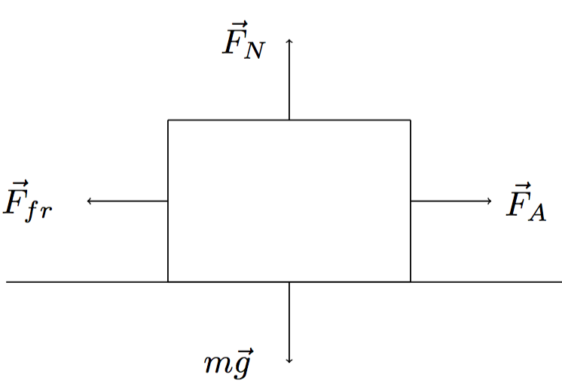

Figure 1.

Figure 1 shows four forces acting on an object that sits on a horizontal plane. $\vec{F_{A}}$ corresponds to some applied horizontal force. $m\vec{g}$ is the force of gravity on the object, which is matched equally but in the opposite direction by the normal force, $\vec{F_{N}}$. The normal force is a result of a surface acting on an object in opposition to gravity. The normal force explains why a book does not simply fall through the table it is resting upon. Finally, opposing the applied force is the frictional force, $\vec{F_{fr}}$. The frictional force is proportional to the normal force:
$\vec{F_{fr}}=μ_{k}*\vec{F_{N}}$, (Equation 1)
where $μ_{k}$is the coefficient of friction.
The coefficient of friction must be measured experimentally and is a property that depends upon the two materials that are in contact. There are two types of coefficients of friction: kinetic friction, $μ_{k}$, when objects are already in motion, and static friction, $μ_{s}$, when objects are at rest and require a certain amount of force to get moving. For an object sliding along a path, the normal force is equal to the weight $m\vec{g}$ of the object. Therefore, the frictional force depends only upon the coefficient and the mass of an object.
If the object is on an inclined plane, then the normal force $\vec{F_{N}}$ is perpendicular to the incline and is not equal and opposite to the weight $m\vec{g},$as can be seen in Figure 2.
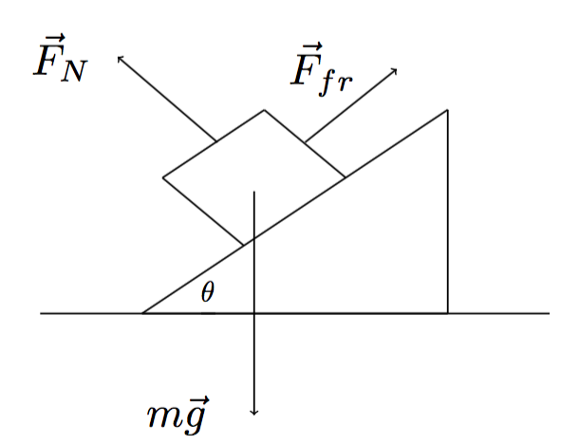

Figure 2.

In this case, only a component of $m\vec{g}$ is equivalent to the normal force, depending on the angle $θ$:
$\vec{F_{fr}}=μ_{k}*\vec{F_{N}}=μ_{k}*m\vec{g}*cos\left(θ\right)$. (Equation 2)
The angle of repose $\left(θ_{R}\right)$ is defined as the point at which the force of gravity on an object overcomes the static friction force and the object begins to slide down an inclined plane. A good approximation for the angle of repose is:
$tan\left(θ_{R}\right)=μ_{s}$. (Equation 3)
In this lab, two metal pans will be used to represent materials with different coefficients of friction. Block A will have a sand paper bottom, which will result in a higher coefficient of friction, while block B will have a smooth metal bottom.

Procedure
1. Measure the coefficients of friction.
  - Add a 1,000-g weight to each block and use a scale measure the masses of blocks A and B, including the added mass.
  - Connect the force scale to block A. Pull the scale horizontally and note the reading just before the block begins to slide. Just before it begins to slide, the maximum amount of static friction is resisting the movement. Use the force reading to calculate $μ_{s}$for block A. Do this five times and record the average value.
  - Repeat step 1.2 with block B.
  - Pull block A across the table at a constant speed. If the speed is constant, then the force reading on the scale should be equal to the frictional force. Calculate $μ_{k}$for block A. Do this five times and record the average value.
  - Repeat step 1.4 with block B.
2. Effect of weight on the force of friction.
  - Place block A on top of block B and repeat step 1.4 five times, determining the average value. Calculate the factor by which the frictional force increased/decreased.
  - Place block B on top of block A and repeat step 1.4 five times, determining the average value. Calculate the factor by which the frictional force increased/decreased.
3. Effect of surface area on force of friction.
  - Turn block B onto the side that contains only the rim of the pan. The weight will need to be placed on the top of the face-up side. Measure the force of friction and compare it to the value measured in step 1.2. Calculate the factor by which the frictional force increased/decreased.
4. Angle of repose.

  - Place block A on the adjustable incline plane, starting at an angle of 0°. Slowly raise the angle until the block begins to slide. Using a protractor, measure the angle of repose and use Equation 3 to calculate the coefficient of static friction just before the block began to slide. Do this five times and record the average value.
  - Repeat step 4.2 with block B.

Results:
Table 1. Coefficients of friction.
Block | $$μ_{s}$$ | $$μ_{k}$$
A | 0.68 | 0.60
B | 0.52 | 0.47

Table 2. Effect of weight and surface area on the force of friction.
Measurement | $$\vec{F_{fr}}$$  (N) | Factor by which it is larger or smaller
Block B on A | 16 | With $\vec{F_{fr}}$from step 1.4 = 2.3
Block A on B | 14 | With $\vec{F_{fr}}$ from step 1.5 = 2.5
Small surface area | 5 | With $\vec{F_{fr}}$ from step 1.4 = 0.9

Table 3. Angle of repose.
Block | Angle of repose $\left(θ_{R}\right)$  (°) | $$μ_{s}$$
A | 30 | 0.58
B | 24 | 0.45

The results obtained from the experiment match the predictions made by Equations 1 and 2. In step 1, the static friction was larger than the kinetic friction. This is always the case, as more force is required to overcome friction when an object is not already in motion. In step 2, it was confirmed that the force of friction was proportional to the weight of both blocks and the coefficient of kinetic friction of the block in contact with the table. The result of step 3 confirms that the surface area does not affect the force of friction. In step 4, the angle of repose can be approximated by Equation 3. The error associated with the lab comes from the difficulty of reading the force scale while maintaining a constant velocity for the sliding block. By taking several measurements and calculating the average, this effect can be reduced.

Applications and Summary
Friction is everywhere in our daily lives. In fact, it would not be possible to walk without it. If someone tried walking on a frictionless surface, he would go nowhere. It is only the friction between the bottom of his feet and the ground as his muscles push against the ground that propels him forward.
In almost every aspect of industry, engineers are trying to reduce friction. When two surfaces are in contact, there will always be friction. This can take the form of heat, such as the heat felt when someone quickly rubs her hands together. In industrial applications, this heat can damage machines. Friction forces also oppose the motion of objects and can slow done mechanical operations. Therefore, substances like lubricants are used to decrease the coefficient of friction between two surfaces.

Table 4. Example coefficients of friction.
Materials | $$μ_{k}$$
wood on wood | 0.2
brass on steel | 0.44
rubber on concrete | 0.8
lubricated ball bearings | < 0.01

In this experiment, the coefficients of static and kinetic friction were measured for two different sliding blocks. The effect of mass on the force of friction was examined, along with the effect of surface area. Lastly, the angle of repose for a block on an inclined plane was measured.

