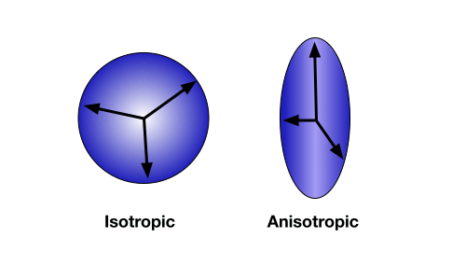
Figure 1: Diffusion anisotropy. When the direction of diffusion is unconstrained and random, movement is measured in all directions equally. This is isotropic diffusion (left). When water molecules are contained within the axon of a neuron, diffusion is anisotropic, tending to occur more frequently along the direction of the axon (right).

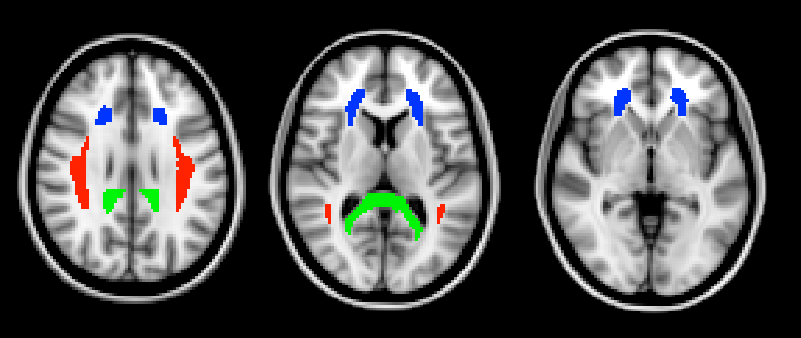

Figure 2: Regions of interest. The three ROIs defined from the ICBM DTI-81 atlas, shown here in horizontal slices through the brain. In green is the splenium of the corpus callosum. The splenium is the most posterior part of the corpus callosum. In blue is the anterior corona radiata. The superior longitudinal fasciculus is shown in red.

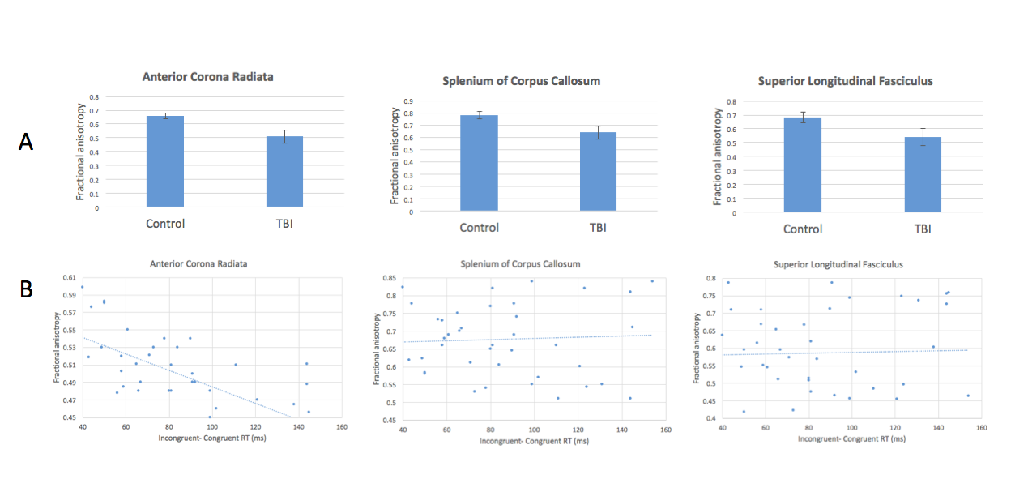

Figure 3: Reduced anisotropy in patients with TBI and relationship with attentional control. (A) FA values are significantly lower in TBI patients compared with healthy controls in all 3 ROIs. (B) FA in the anterior corona radiata correlates negatively with increased incongruency effect in the attention task. The other two ROIs show no significant relationship.

