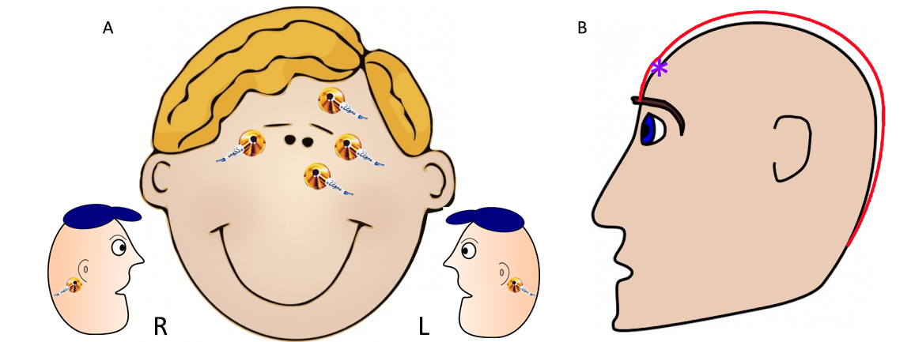

Figure 1: Electrode placement. Placement of the face electrodes to detect EOG artifacts and record mastoid movement (A). Diagram of measurement from directly between the eyebrows to just under the bump in the back of the head. 10% of this measurement is measured above the mid-eye mark, and this is where the FPZ electrode of the cap is placed (B).

Figure 2: Study design for the oddball task. The participant is presented with either a red circle or a green circle. Each stimulus appears for 1 second, followed by a 2 second blank screen. Each time the participant sees a green circle, he is instructed to press a button held in his right hand.

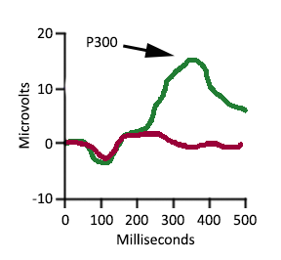

Figure 3: P300 Parietal Response to Baseline and Oddball images. Average ERP time trace of the parietal response to baseline images (red) and oddball images (green). The response is measured in microvolts over milliseconds.

