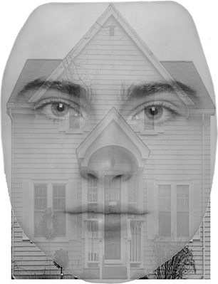

Figure 1. Face stimulus and house stimulus superimposed together. Each stimulus presented was a superimposed face and house. The participant was instructed to focus on either the face or the house.

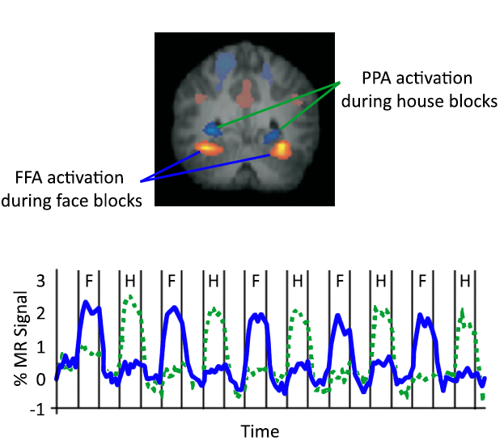

Figure 2. Localizer for the Fusiform Face Area (FFA) and the Parahippocampal Place Area (PPA). Example of a single subject localization of the FFA during blocks of viewing faces and the PPA during block of viewing houses (top). Signal in the FFA was increased during blocks of faces but not houses (blue), and signal in the PPA was increased during blocks of houses but not faces (green).

Figure 3. Activation in the Fusiform Face Area (FFA) and the Parahippocampal Place Area (PPA) during attention switching task. When attention was on the house (green), PPA showed increased activation while FFA did not. Reversely, when focus was on the face (blue), FFA showed increased activation while PPA did not.

