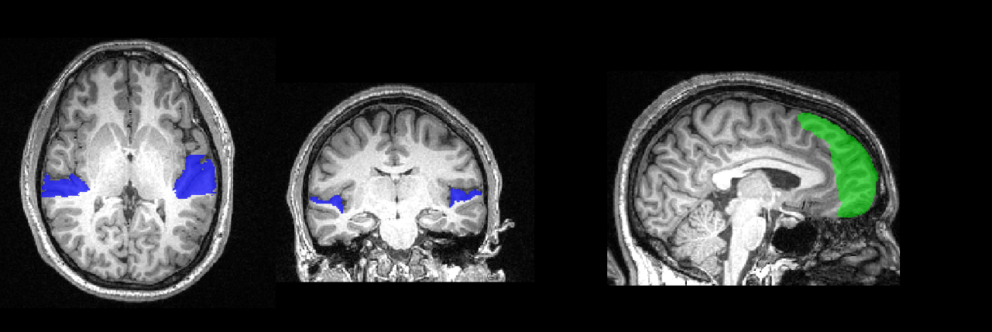

Figure 1: Region of interest tracing. The surface of the planum temporale has been traced on this participant’s high resolution anatomical image, and is shown here in blue. In green is the control mask of the frontal pole. These voxels will be used for MVPA analysis.

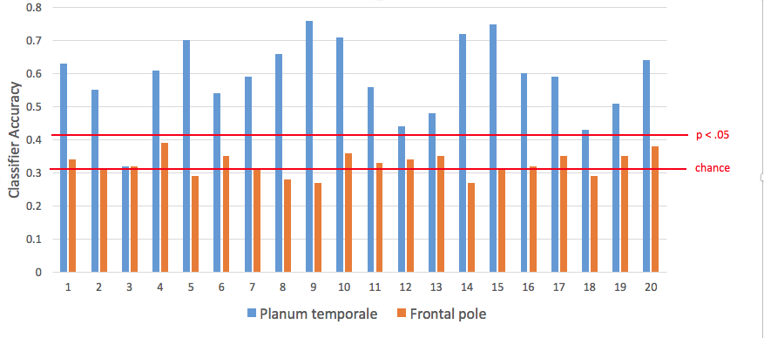

Figure 2. Classification performance in each participant. For three-way classification, chance performance is 33%. According to a permutation test, the alpha level of p < .05 corresponds to 42%.

