Figures
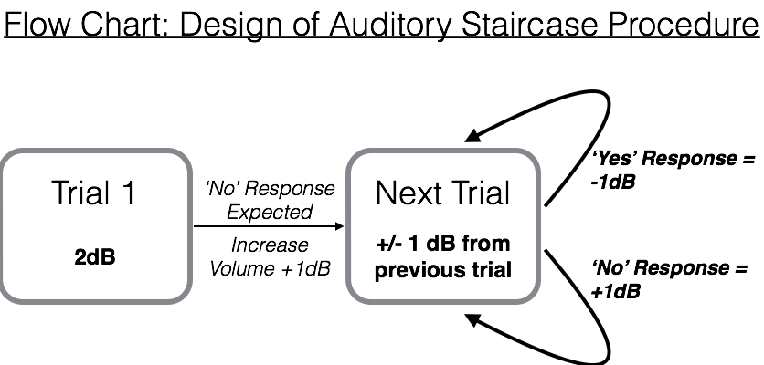
Figure 1. A flow chart for the design of an experiment using the auditory staircase procedure. The first trial always involves a tone played at an inaudible volume of 2dB. Because the participant should not detect that tone, a ‘No’ response will be given, and the volume in the next trial will be increased by 1dB (to 3 dB). Every trial (including and) following the second proceeds with the same directive: If a ‘Yes’ response is supplied by the participant, the volume in the next trial is reduced by 1dB. And if a ‘No’ response is supplied, the volume in the next trial is increased by 1dB. An experiment will include 30 trials per frequency.

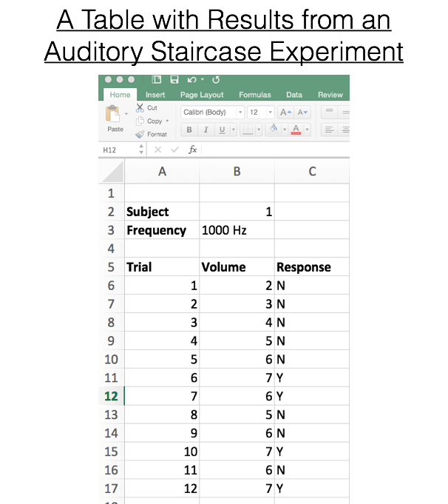
Figure 2. A sample of a table that includes the required outputs from an auditory staircase experiment. Note that data reported are for a single subject (labeled Subject #1) and for a single frequency (1000 Hz). The table includes three columns: the trial number, the volume of the tone presented on that trial (dB) and the response given by the participant.

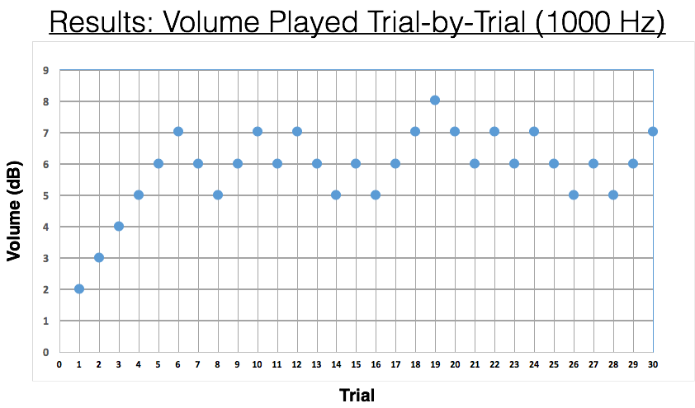
Figure 3. Sample results from a single participant and with a single tone. The graph plots the volume of the tone played, in Decibels (dB), as a function of the trial number for each of the 30 trials. The main pattern is that the participant cannot hear any tone in the first few trials, producing a series of ‘No’ responses and prompting volume increases until the auditory threshold is reached. At that point, the participant moves back and forth between ‘No’ and ‘Yes’ responses allowing the researcher to identify the place at which sounds first become detectable.

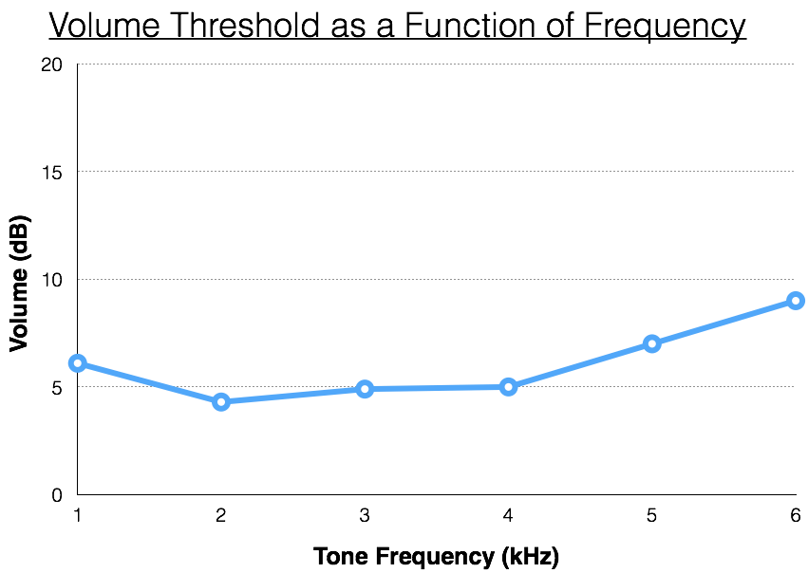
Figure 4. Volume threshold as a function of frequency. Data shown are for a single participant, age 20 yrs. Because of the structure of the human auditory system, sounds with lower frequencies —what are colloquially called lower pitched or deeper— are easier to hear than high frequency (high-pitched) sounds. It takes a larger volume to make a high frequency sound audible.
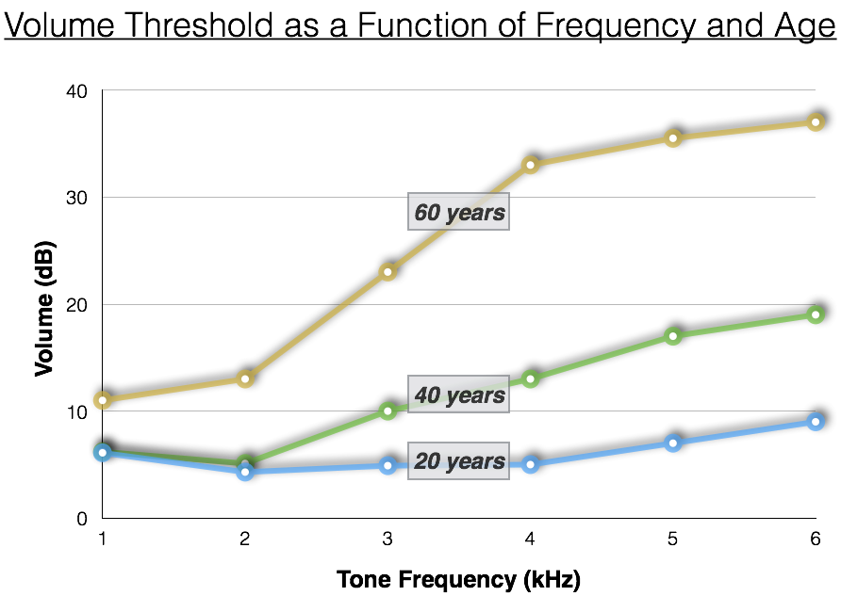
Figure 5. Volume thresholds as a function of frequency and age. In general, volume thresholds increase as people age. In addition, the disparity between low and high frequency sounds grows. To be audible to someone aged around 60 a high frequency sound needs be almost 4 times as loud as it would have been to be audible by someone aged 20.

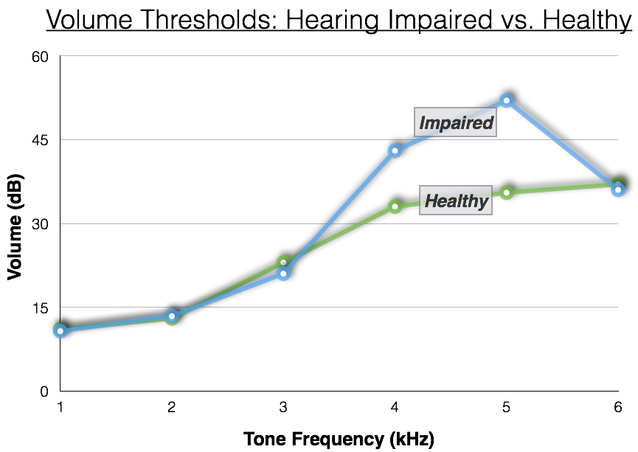

Figure 6. Volume thresholds for a hearing impaired individual (60 yrs) compared with an unimpaired age match. Hearing impairment often affects only a portion of frequency space. The impaired individual shown here suffers severe impairment —very high thresholds— at 4 and 5 kHz, but appears otherwise normal compared with an age matched control.

