Figures
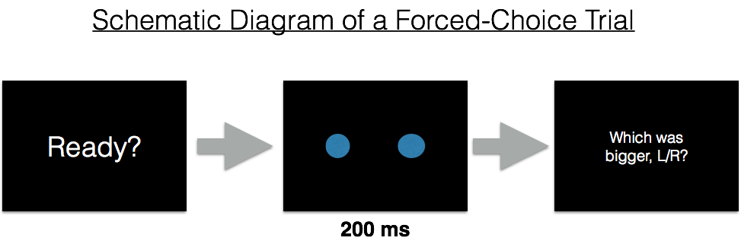
Figure 1. A schematic depiction of a single forced-choice trial in an experiment to measure the Just-Noticeable-Difference (JND) for circle size. First, a ready screen prompts the participants that a trial will begin. Next, two blue discs appear in the display, side-by-side. They remain present for only 200 ms, at which point the display prompts the participant for a response. The L key is used to indicate the object on the left, and the R key to indicate the object on the right.

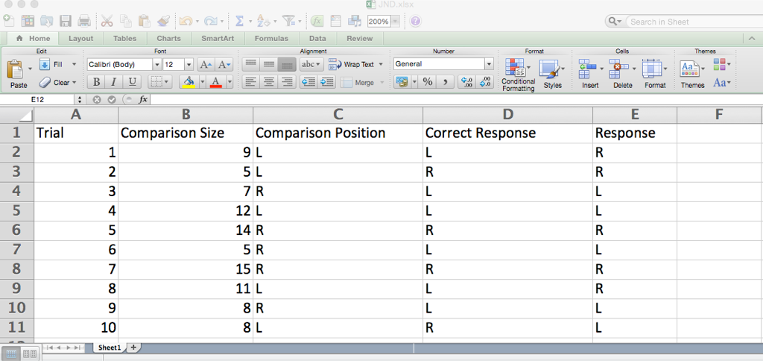

Figure 2. A sample output table from a forced-choice JND experiment. The columns report the relevant data from the experimental program.

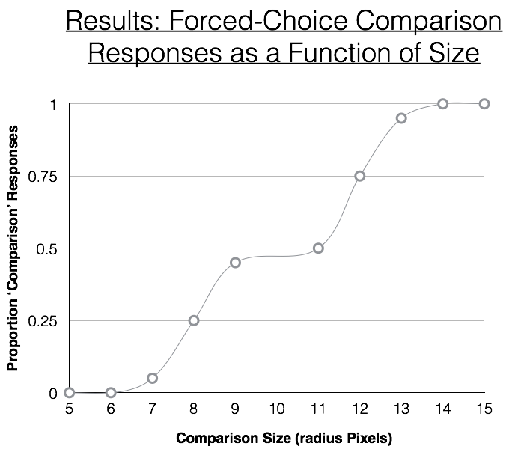

Figure 3. Results of a forced choice experiment to find the JND for circle radius. Plotted is the proportion of time that the ‘Comparison’ stimulus was selected as larger (by the participant) as a function of the size of the Comparison stimulus. The Constant stimulus always had a radius of 10 pixels.
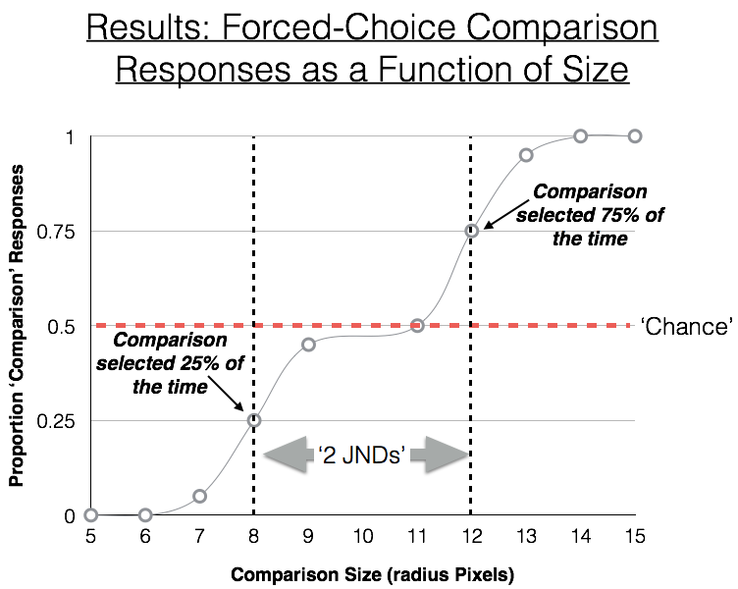

Figure 4. An annotated version of Figure 3.

