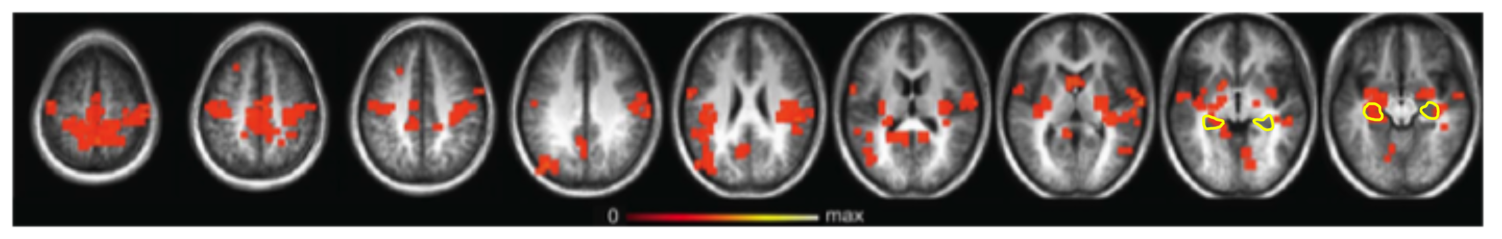

Figure 1. Remember minus Know. Cluster map of Remember minus Know (p < .01, corrected for multiple comparisons). Hippocampus is outlined in yellow. Clusters are overlaid on an average anatomical brain of the study participants.

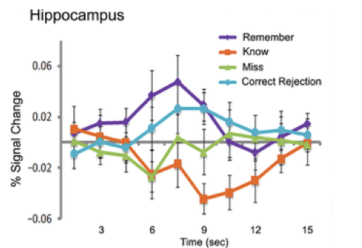

Figure 2. Hippocampal activity over time. Each line shows activity in the hippocampus over the course of trials of each type. “Remember” and “Know” are trials in which participants correctly reported remembering the stimuli. “Miss” trials refer to stimuli that were presented before but not correctly remembered by the participant. “Correct rejections” are new stimuli that participants correctly identified as new. Y-axis is percent signal change from baseline; X-axis is time (s) after the onset of the stimulus.

