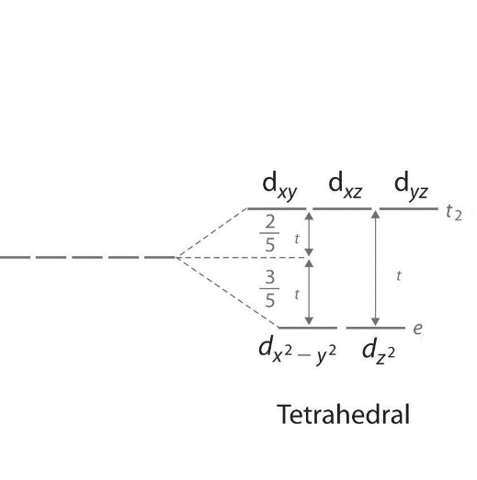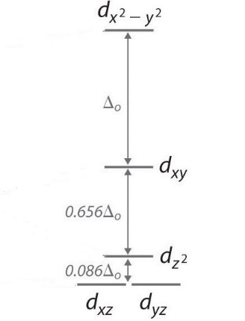
Figure 2. Tetrahedral and square planar d-orbital splitting. Redraw. Image is from chemwiki.ucdavis.edu.

