PI: Linus Pauling
Chemistry Science Education Title:
Preparing for Matrix-assisted Laser Desorption/Ionization Time of Flight (MALDI-TOF) Mass Spectrometry Experiments

Overview: Matrix-assisted laser desorption/ionization (MALDI) is a soft ionization technique (unlike electron ionization or ICP) used in mass spectrometry, allowing the analysis of biomolecules (biopolymers such as DNA, proteins, peptides, and sugars) and large organic molecules (such as polymers, dendrimers, and other macromolecules).
MALDI is a two-step process. First, the sample for MALDI is uniformly mixed in a large quantity of matrix and the matrix is absorbed onto a metal plate. Second, desorption is triggered by a UV laser beam.
Time-of-flight is a mass selection technique used to differentiate ions by m/z. The simultaneous transmission of all ions and the rapid flight time means that the detector can capture the entire mass spectral range almost instantaneously.
This video will explain the process of cleaning the MALDI plate, followed by sample deposition. The process of obtaining spectra will be explained briefly and an example of MALDI-TOF analysis shown for a human antibody.
Principles: Matrix material heavily absorbs UV laser light, leading to vaporization (~1 μm) of the matrix that contains the sample. During vaporization analyte molecules are ionized (more accurately protonated or deprotonated).
TOF-MS involves applying an electric field to the vaporized sample matrix, so that ionized analyte molecules are propelled toward a detector. The speed with which analytes move toward the detector is dependent on the mass charge ratio of the particular analyte. Smaller, more highly charged ions have a shorter time of flight before hitting the detector. The time of flight can be used to identify and distinguish between analytes within a sample.
Procedure:
- Cleaning of MALDI Stainless Steel Target

  - Rinse the MALDI plate with methanol (MeOH) and wipe gently with a cleaning tissue specially made for laboratory applications (e.g. Kimwipe).

  - Rinse the target with H₂O and wipe it with a cleaning tissue.

  - Insert the MALDI plate in a 600 ml beaker and cover it with 50% EtOH.

  - Sonicate the target in the EtOH solution for 10 min in an ultrasonic bath.

  - If there are residues remaining on the plate, repeat the steps 1-4 once again.

  - Finally, rinse the target with MeOH (or with water, see the note below), tilt it in a way that all the liquid is collected on a cleaning tissue. Let the target dry at room temperature or using a nitrogen-gas flow.

- Preparation and Deposition of Matrix on MALDI Target

  - Dissolve desired matrix (ex., α-CHCA: α-cyano-4-hydroxycinnamic acid) in acetone in order to make a saturated solution.
  - Dip a 10 μl pipette tip in the saturated solution so that a small amount of the solution flows in the tip.
  - Touch the MALDI target rapidly with the pipette tip to deposit the matrix solution on the MALDI target.

- Sample Deposition on the MALDI Target and MALDI Spectra Acquisition

  - Next, deposit 0.5 μl of the protein sample on the prepared thin layer of matrix on the plate. Immediately after this, add 0.5 μl of the matrix solution.
  - Protein sample is mixed with the matrix directly in a 1:1 ratio, which is critical for good quality.
  - Deposit 0.5 μl of the calibrant standard on the MALDI plate and then add 0.5 μl of the matrix solution.
  - Once the samples and the calibrant are dried, you can observe the “spots” under a microscope.
  - Insert the target into the instrument and choose the appropriate instrument set up.
  - Then, choose the appropriate m/z range, acquire the spectra of the calibrant, and calibrate the instrument.
  - Using the appropriate laser intensity, acquire the spectra of the protein samples.

- Results: MALDI-TOF Analysis of Proteins Larger than 100 kDa
  - MALDI-TOF analysis of an intact immunoglobulin absorbed to the target plate in different matrices is shown here. The spectra obtained using a CHCA_DHB (cyano-4-hydroxycinnamic acid; 2,5-dihydroxybenzoic acid) mixture were much more intense than the SA (sinapinic acid) and α-CHCA (α-cyano-4-hydroxycinnamic acid)spectra (. More specifically, the protein signals were higher and had better resolution in the CHCA_DHB spectra. The use of the CHCA_DHB mixture and the thin layer deposition method demonstrated significant improvements in the quality of large intact protein mass spectra acquired using a MALDI-TOF instrument.

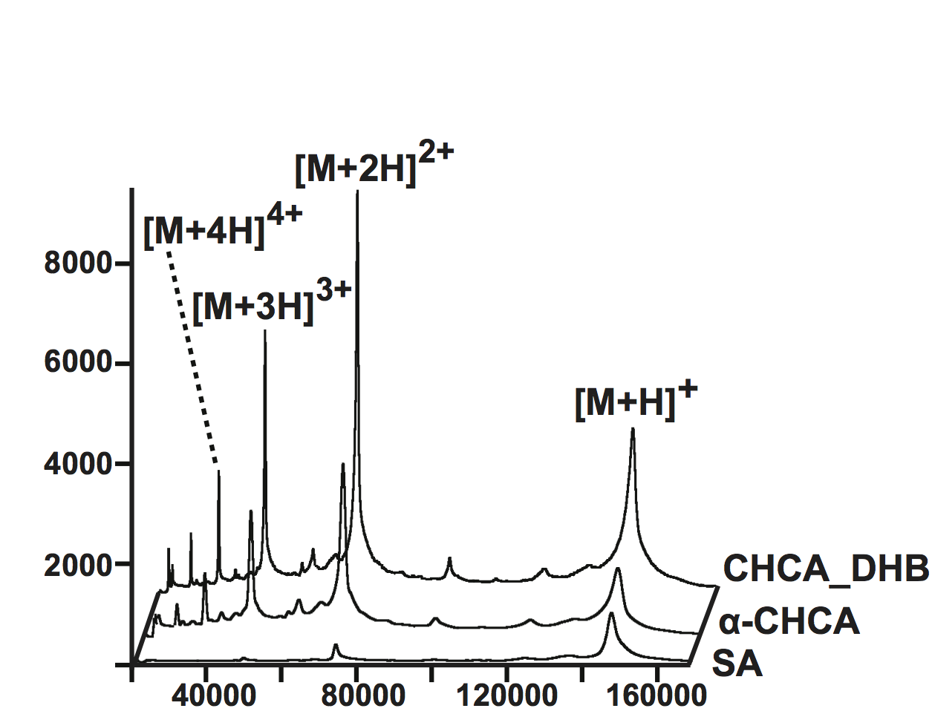
Figure 1. MALDI-TOF analysis of an intact immunoglobulin, IgG. MW: 148,500 Da; amount: 1.7 pmoles. The spectra obtained using the CHCA_DHB mixture were much more intense (maximum: 8,200) than the SA spectra (maximum: 1,200) and α-CHCA spectra (maximum: 4,500).

- Applications: MALDI can be applied and used in fields ranging from biochemistry, molecular biology, and microbiology. In proteomics, MALDI is used for the rapid identification of proteins isolated by using gel electrophoresis: SDS-PAGE, size exclusion chromatography, affinity chromatography, strong/weak ion exchange, isotope-coded protein labeling (ICPL), and two-dimensional gel electrophoresis. Peptide mass fingerprinting is the most popular analytical application of MALDI-TOF mass spectrometers. MALDI TOF/TOF mass spectrometers are used to reveal amino acid sequence of peptides using post-source decay or high-energy collision-induced dissociation (further use see mass spectrometry).

In molecular biology, a mixture of 5-methoxysalicylic acid and spermine can be used as a matrix for oligonucleotides analysis in MALDI mass spectrometry, for instance after oligonucleotide synthesis.

MALDI/TOF spectra are used for the identification of microorganisms such as bacteria or fungi. A colony of the microbe in question is smeared directly on the sample target and overlaid with matrix. The mass spectra generated are analyzed by dedicated software and compared with stored profiles. Species diagnosis by this procedure is much faster, more accurate, and cheaper than other procedures based on immunological or biochemical tests. MALDI/TOF may become the standard method for species identification in medical microbiological laboratories over the next few years.

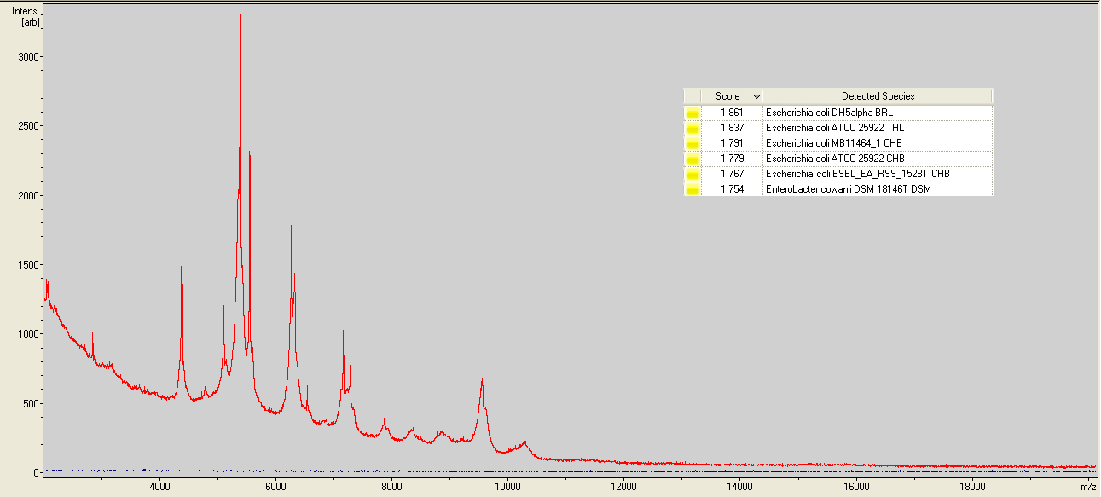
Figure 2. The MALDI-TOF MS generated spectra for Escherichia coli. To the right is the first 5 matches identified by the Typing software. Note that the species is consistently reported as Escherichia coli. With the score of 1.861 and with the top 5 matches being E. coli the identification is considered reliable to species level.

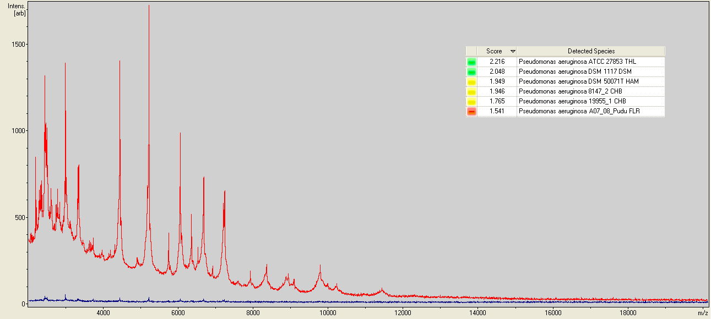
Figure 3. The MALDI-TOF MS generated spectra for Pseudomonas aeruginosa. To the right is the first 5 matches identified by the Typing software. Note that the species is consistently reported as Pseudomonas aeruginosa. With the high score of 2.216 the identification is considered reliable to species level of identification.

