Video Comments: 10164

Time-code |  | Comment | Suggestion
1. | 00:04 | Title card splash is different from 10114 and 10151 | All three are different and should be the same.
2. | 00:19 | Depiction of current is different in each video. Current typically shown as red | Choose one way to depict current
3. | 00:19 | AC symbol should be replaced with DC symbol | Replace AC symbol 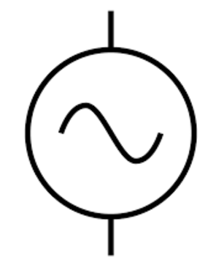  with DC symbol.  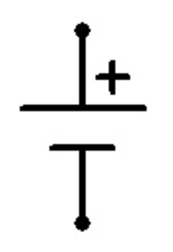
4. | 02:30 | AC symbol should be replaced with DC symbol | Replace symbol (see number 3.)
5. | 02:42 | Replace AC symbol on coil on the right as well | Replace symbol with DC symbol. (See 3,4)
6. | 05:05-05:12 | Remove shots | VO shortened, so shots at 05:05-05:12 can be removed.
7. | 05:26-05:31 | Remove shot of function generator | Only show the following shot (at 5:32) showing the waves on the oscilloscope and hold there. The VO is talking about the wave on that screen.
8. | 05:37-05:44 | VO shortened. Only show Author Figure 1 | Show Author Figure 1 which shows how the circuit should be assembled. VO shortened (see below)
9. | 05:44-05:56 | VO shortened. Hold on screen shot, and do not pan across | Hold on screen shot and do not pan across.
10. | 07:47 | Make “C” in title lower case | B-H curve of a 60 Hz transformer
11. | 07:51-07:59 | Remove shot and VO | Remove shot and VO
12. | 08:00-08:09 | Show 10151@ 01:34-01:45 (remove text at bottom of animation) | Show animation from 10151 only, and remove prior shot from 52816 and following shot of transformer on the bench (08:05-08:09)
13. | 08:10-08:11 | Shot cuts off too quickly. | Shot of talent plugging in to the function generator should run from 08:10 to 08:17 and should not cut off at 08:11
14. | 08:11-08:17 | Remove shot entirely | Remove shot entirely. See above (number 13)
15. | 08:23-08:29 | Remove shot and VO entirely | Remove shot and VO entirely
16. | 09:04 | Change title card | “Representative Results”
17. | 09:07-09:17 | Remove shot and VO entirely | Remove shot and VO entirely
18. | 10:00 | Right top and right bottom squares on quad panel are white | Add footage
19. | 10:11-10:36 | Remove application 1 | Remove application 1
20. | 11:19-11:49 | Insert animations from 10150 | Insert animations from 10150
21.

Audio Comments:

Time code |  | Comment | Step in Script (ex 4.2) | Rewritten Text or Corrected Pronunciation
1. | 04:00 | Change VO | 2.7.1 | Now, let’s demonstrate how to measure relative permeability and calculate B-H curves.
2. | 04:32 | Change VO | 3.1.1 | Start with the small inductor with dimensions as shown and a winding turns number of 75.
3. | 04:58 | Change VO | 3.4.1 | Next, connect the differential voltage and current probes, and verify that there are no offsets.
4. | 05:06 | Change VO | 3.5.1. | Set the differential probe to 1/20 for a better resolution. Finally, set the current probe to 100 mV/A on the probe and 1X on the scope, and note these scaling factors for later calculations
5. | 05:26 | Change VO | 3.6.1 | Set the function generator output to a 1000 Hz sinusoidal waveform with a 10 V peak.
6. | 05:37 | Change VO | 3.7.2 | Connect the function generator, and verify that all circuit connections are as shown. Then record the measured current and voltage.
7. | 06:43 | Change VO | 4.1.1 | To determine the number of turns for the larger inductor, let’s first measure its BH curve. In order to simplify calculations, assume the core is an all-air-core.
8. | 07:06 | Change VO | 4.2.1 | First, measure the inductance at 120 and 1000 Hertz using the LCR meter. Then, place the inductor in the RC circuit.
9. | 07:21 | Change VO | 4.3.1 | Observe and record the measured current and voltage.
10. | 07:30 | Change VO | 4.4.1 | Display the B-H curve, adjust the function generator frequency to 120 Hz and adjust the curve settings as needed.
11. | 07:54 | Change VO | 5.1.2 | Single-phase transformers consist of two windings coupled by a magnetic core.
12. | 08:19 | Change VO | 5.2.6 | Then assemble the circuit by connecting AC1 and N from the VARIAC to the transformer primary side through the proto board circuit using banana cables
13. | 08:40 | Change VO | 5.3.1 | Adjust the scaling factors and function generator parameters as previously described.
14. | 08:48 | Change VO | 5.4.1 | With the VARIAC at 90%, measure the current and voltage, then display and record the B-H curve.
15. | 10:00 | Change VO | 7.1.1 | Inductors and other electro-magnetic devices, like transformers, are common in many electrical, electronic, and mechanical systems.
16.
17.
18.
19.
20.

