Video Comments: 10150 AC Induction Motor
Time-code |  | Comment | Suggestion
5. | 00:28 | Rotor should be rotating | Add effect to make the rotor look like it is rotating.  This comment was addressed before, and the following note was left by the editor. Please check: The image is a 2D Illustrator file. I’ve created a 3d version that spins, but it doesn’t match the style of the illustration.
2. | 05:26 | Three switches in the schematic are drawn open (diagonal lines), and they should be closed (horizontal lines).  Open- as animated currently:  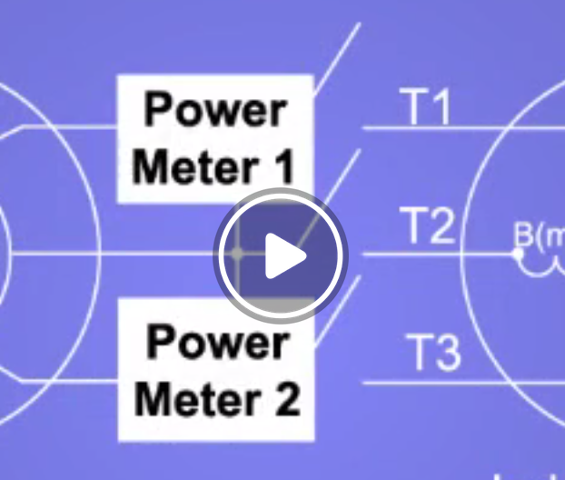 | Redraw schematic to close the three switches.  Closed- Please modify to look like this:  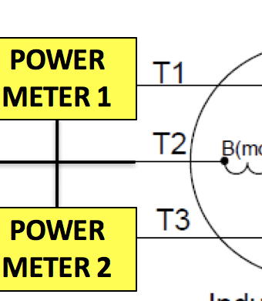
3. | 09:37 | Incorrect shot | Use shot 6.3.2 where Talent connects resistor to apparatus. Series terminals of dynamometer are visible in shot and show nothing connected to them. Talent looks at switch S_{D} and sets it to the open position.

Audio Comments:
Time code |  | Comment | Step in Script (ex 4.2) | Rewritten Text or Corrected Pronunciation
1. | 1:28 | Modify VO: “The resulting net magnetic field, called the stator magnetic field, rotates with constant velocity.” | 2.1.2 | Change to: “The resulting net magnetic field, called the stator magnetic field, rotates with constant angular velocity.”
2. | 4:52 | Modify VO: “First, disconnect all terminals of the DC motor so it generates no power and provides no mechanical load to the induction motor.” | 4.1.2. | Change to: “First, disconnect all terminals of the DC generator or dynamometer so it generates no power and provides no mechanical load to the induction motor.”
3. | 6:53 | Modify VO: “For this test, use the setup of the no load test and disconnect all terminals of the load monitor.” | 5.1.2. | Change to: “For this test, use the setup of the no load test and disconnect all terminals of the DC generator or dynamometer.”
4. | 9:24 | Modify VO: “For this test a DC motor is connected to the induction motor so that it provides a controlled load on the rotor.” | 6.2.2. | Change to: “For this test a DC generator or dynamometer is connected to the induction motor so that it provides a controlled load on the rotor.”
5. | 09:56 | Modify VO : Remove: “A plot the induction motor torque… “ | 7.4 | Change to: A plot of the induction motor torque-speed characteristics will be like these curves for the four classes of NEMA motors.

