PI: Jonathan Flombaum
Psychology Education Title
Measuring Reaction Time and Donder’s Method of Subtraction
Overview: The ambition of experimental psychology is to characterize the mental events that support the human ability to solve problems, perceive the world, and turn thoughts into words and sentences. But people can’t see or feel those mental events; they can’t be weighed, combined in test tubes, or grown in a dish. Wanting to study mental life, nonetheless, Franciscus Donders, a Dutch ophthalmologist in the early 1800s, came up with a property that he could measure —even back then: he measured the time it took for human subjects to perform simple tasks, reasoning that he could treat those measurements as proxies for the time it takes to complete the unobservable mental operations involved. In fact, Donders went one step further, developing a basic experimental paradigm known as the Method of Subtraction. It simply asks a researcher to design two tasks that are identical in nearly every way, excepting a mental operation hypothesized to be involved in one of the tasks and omitted in the other. The researcher then measures the time it takes to complete each task, and by subtracting the outcomes, she extracts an estimate of the time it takes to execute the one mental operation of interest. In this way, the method allows a researcher to isolate a mental operation. The time it takes to complete a task has become known as ‘reaction time’ or ‘latency.’ Even today, reaction time is by a wide margin the most prevalent dependent variable in experimental psychology.
This video will demonstrate the measurement of reaction time using Donder’s Method of Subtraction
Procedure
- Pick a task and material to implement it

  - To use Donder’s Method of Subtraction, one first needs a mental operation of interest, and a pair of tasks thought to differ in terms of the operation. For current purposes, this video explores the ability to resolve conflicts between different sources of information —an important aspect of the ability to exert self-control on behavior. The Stroop task is a good basis for measuring the time it takes to resolve a conflict between information sources.
  - The Stroop task can easily be programmed on a computer, but one nice feature is that it can also be implemented with just a few index cards and magic markers.
  - So, the first things needed are four magic markers, one each in red, yellow, blue, and green, and also two large index cards and a stopwatch.

- Making the ‘No Conflict’ stimuli

2.1 Take one of the index cards, placing it in front of you so that the lines are horizontal. Fold it in half creating a vertical meridian for two columns of stimuli.
2.2 On each line in the left column, write in clear, capital letters one of the four color-terms, ‘RED, YELLOW, BLUE, GREEN.’ Ink each word using its corresponding magic marker. You want to pick colors more-or-less randomly. It might be easier to do this by rolling a die with one of the four colors assigned to each number.
2.3 Repeat 2.2 on each line of the right column, aligned with the crease in your card.
2.4 You now have the stimuli for the ‘No Conflict’ condition of this classic experiment.
3. Making the ‘Conflict’ stimuli
3.1 Take your second index card, and repeat step 2.1.
3.2 Now you are again going to write out a color term on each line and in each column. But crucially, ink each term with any marker except for the corresponding color. In other words, create a conflict between the ink color and the word you write on each line. Again, you want to pick words and colors more or less randomly. If you are using a die, you can roll it once to pick your word, and again to pick your ink (rolling again if they happen to match). Or you can use to dice, of course.
3.3 You know have the stimuli for your ‘Conflict’ condition. Note, your ‘Conflict’ and ‘No Conflict’ cards should have equal numbers of words.
4. Testing a participant
4.3 You are now ready to test your first participant. You can also test yourself —but you’ll need someone to run the stopwatch.
4.4 Place either one of your index cards face down on a table in front of your participant.
4.5 Set your stopwatch to 0.
4.6 Explain to the participant that when you say go, she can turn over the card, and as quickly as possible she should look at each line of the index card, working her way down the left column and then the right column, saying out loud the color of the ink. In other words, she should not read the word, only report its ink color. Emphasize that she must report each line correctly before moving on to the next, but that she should try to go as quickly as possible. She should say ‘DONE’ after reporting the final line.
4.7 You say go, activate the timer, and get ready to stop the timer when your subject says, ‘DONE.’
4.8 Write down the time it took.
4.9 Now repeat 4.5 – 4.8, but with the other index card. You want the participant to do the task once with the ‘No Conflict’ stimuli, and once with the ‘Conflict’ stimuli. Order does not matter. But if you were to run multiple participants, you would want to ‘counterbalance,’ with half the participants doing one order and the remaining half doing the other.
5. Analysis
5.1 You should now have two reaction times: the time it took for your participant to get through the ‘Conflict’ card, and the time she took with the ‘No Conflict’ card. Subtract the ‘No Conflict’ time from the ‘Conflict’ time. If the number is positive, it is a sign that resolving the conflict between ink color and written words is a step that is involved in the ‘Conflict’ condition and not the ‘No Conflict’ condition. And the difference is an estimate of how long resolving the conflict takes.
5.2 Note that each card included several words. But because the two cards included the same number of words, the difference between your conditions is best thought of as an estimate of the time to resolve a single instance of conflict. It is the difference between the sums of several instances that included a conflict and as many that did not.
Sample Stroop Stimuli
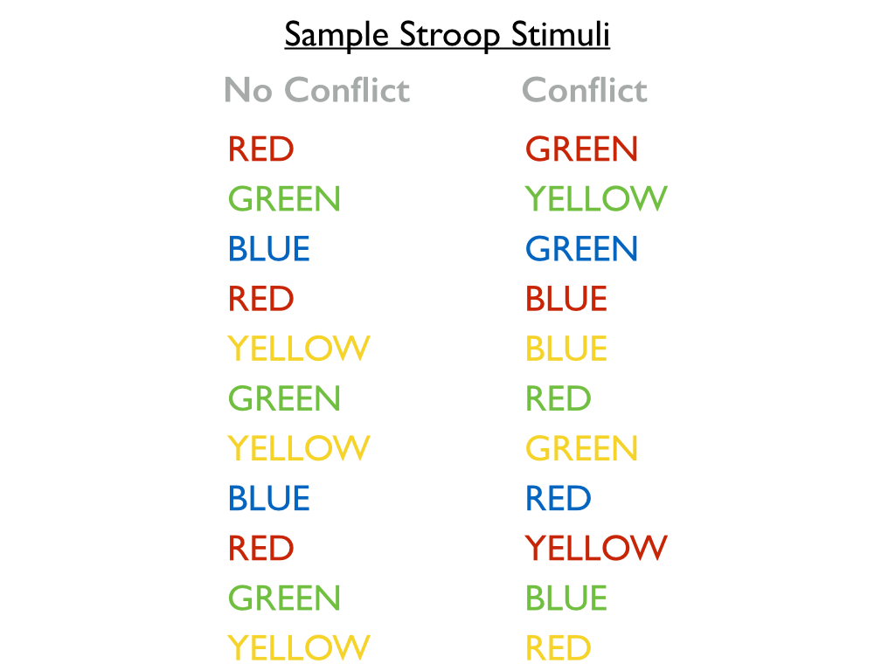
Figure 1 – Sample Stroop Stimuli. No Conflict examples shown on the left, and Conflict examples shown on the right.

Representative Result
It is hard to draw conclusions from a single subject, and so an experiment typically tests many subjects, aggregating their results to draw reliable conclusions. For this Stroop experiment you would test 20 or so participants just the way you tested one. For each participant, you end up with two reaction times, one from the ‘Conflict’ and one from the ‘No Conflict’ condition. On a spreadsheet, we would organize the results something like this:
Subject | Conflict RT (ms) | No Conflict RT (ms)
1 | 7240 | 6189
2 | 8345 | 7194
3 | 7734 | 5238
4 | 6221 | 5715
5 | 9334 | 8273
6 | 4322 | 4718
7 | 8845 | 6293
8 | 7240 | 6189
9 | 8345 | 7194
10 | 7734 | 5238
11 | 6221 | 5715
12 | 9334 | 8273
13 | 4322 | 3654
14 | 8845 | 6293
15 | 7735 | 6497
16 | 6944 | 6227
17 | 5893 | 5265
18 | 9115 | 7836
19 | 8931 | 8110
20 | 6241 | 5578

These results can be summarized with a simple graph of the average reaction time across all participants in each condition:
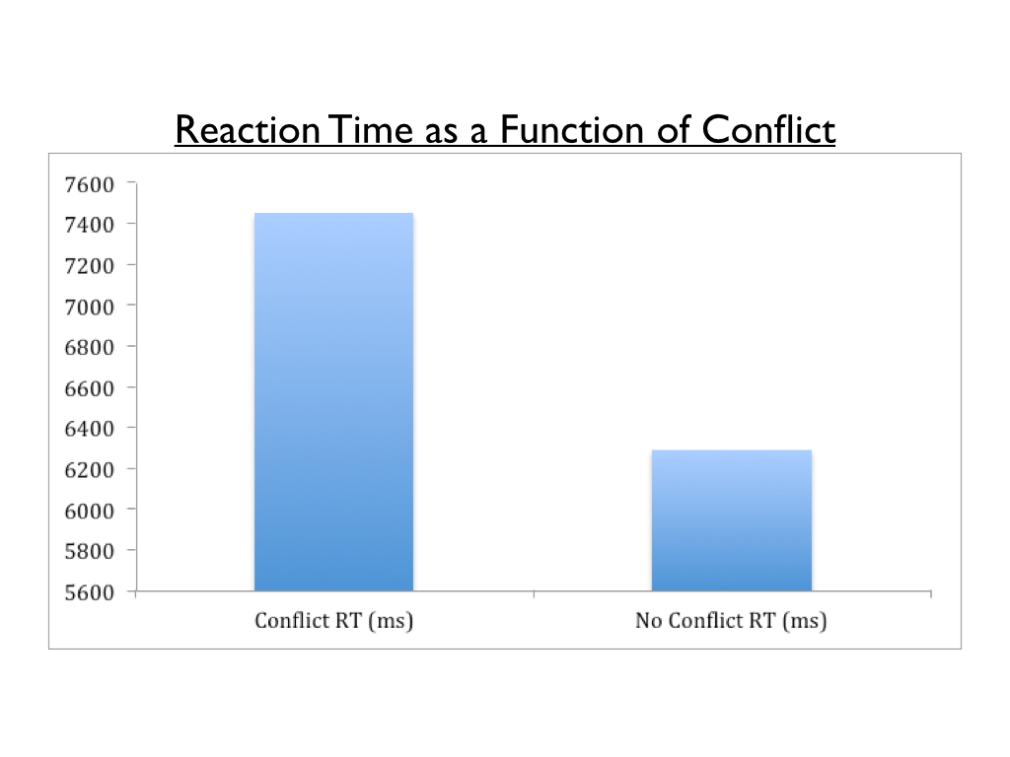
Figure 2 – Reaction time as a function of conflict condition. Participants read through the card with the No Conflict stimuli about 1.2 seconds faster than they read through the card with the Conflict Stimuli. In terms of Donder’s method, this suggests that resolving the conflict between ink color and reading takes about 1.2 seconds per item.

Applications
Donder’s Method of Subtraction can be used with reaction time measures in a variety of areas in experimental psychology, not just with Stroop or conflict paradigms.
In addition, the Method of Subtraction underpins the basic logic for a wide array of approaches to experimental psychology with dependent variables beyond reaction time. These include measures as diverse as how long an infant glares at a stimulus, and the blood-oxygen-level-dependent (BOLD) response measured in the human brain by sophisticated fMRI machines. In many fMRI experiments, researchers obtain patterns of brain activity from two experimental conditions that are identical, excepting the involvement of a mental process of interest. By subtracting one pattern from the other they can isolate brain areas involved in that process. Indeed, the Stroop is a classic example. Participants have their brains scanned during conflict and no conflict trials. Many brain areas are involved in each kind of trial, including visual cortext and regions involved in reading. But when the no conflict scans are subtracted from the conflict ones, fairly isolated frontal regions of the brain —especially one called the anterior cingulate cortex— appear to be critically active in only the no conflict trials. This makes sense! Those frontal regions are often associated with the ability to control one’s own behavior under difficult conditions.

