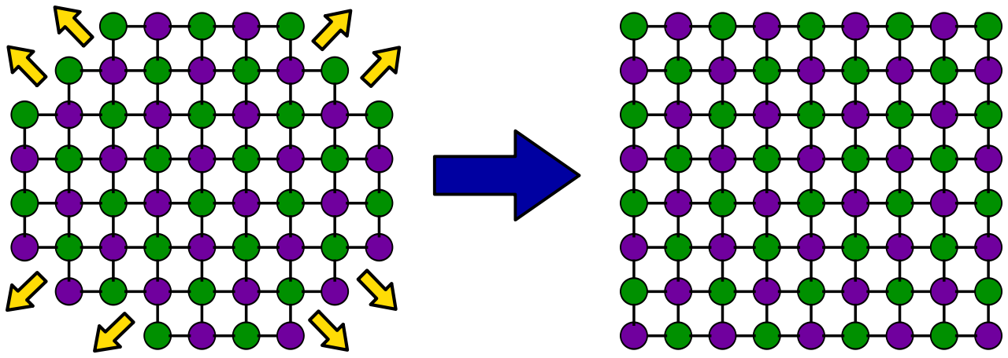

Fig 1 Schematic illustration of why crystals have smooth faces
(taken from: http://en.wikipedia.org/wiki/Crystal)
The rough edges have a lot of dangling bonds, which new atoms can easily bond to as the crystal grows. The smooth planes (with low surface energy and usually low Miller index) have fewer dangling bonds, and new atoms cannot easily attach, so these planes grow outwards more slowly. Eventually you end up with the whole surface being smooth planes. This cartoon is supposed to represent of cross-section of halite: Purple circles are sodium ions, green circles are chloride ions. Image is inspired by a similar one at http://www.its.caltech.edu/~atomic/snowcrystals/faceting/faceting.htm

